# Excel Modifications

* delete all text row except first row
* shift all first cells to the right once
* Type “Date” in the first cell
* convert to csv

# Table 1 Construction

* Difference in the log index price is stored in each dataframe
* If for a given quarter, a country has less than 15 returns, then all the returns of that year for the country in question is marked as NA to remove that period from our analysis.
* Then we see which countries have valid returns for each period in question. If they have valid returns even for one quarter in the given period, then it’s included in the list.

Equity

year

countries

pre 1974

australia austria belgium canada denmark france germany hong.kong ireland italy japan netherlands singapore south.africa switzerland uk us

1974-83

brazil malaysia norway south.korea spain sweden

1984-93

argentina chile china colombia ecuador finland greece hungary iceland india indonesia israel jordan kenya luxembourg mexico morocco new.zealand pakistan panama peru philippines poland slovakia sri.lanka thailand turkey

post 1993

bahrain bangladesh bosnia.and.herzegovina botswana bulgaria cambodia chad côte.d.ivoire croatia cyprus czech.republic egypt estonia georgia ghana iraq jamaica kazakhstan kuwait latvia lebanon lithuania macedonia malta mauritius montenegro namibia nigeria oman portugal qatar romania russia saudi.arabia serbia slovenia trinidad.and.tobago tunisia uganda ukraine united.arab.emirates venezuela vietnam zambia zimbabwe

Bond

year

countries

pre 1986

austria canada france germany ireland japan switzerland uk us

1986-99

australia austria belgium canada denmark finland france germany italy ireland japan netherlands new.zealand norway portugal spain sweden switzerland uk us

post 1999

australia austria belgium canada china czech.rep. denmark finland france germany greece hungary india italy ireland japan mexico netherlands new.zealand norway poland portugal south.africa south.korea spain sweden switzerland uk us

REIT

year

countries

pre 2000

australia belgium canada france germany italy netherlands south.africa uk us

post 2000

australia belgium bulgaria canada france germany greece hong.kong ireland italy japan malaysia mexico netherlands new.zealand portugal singapore south.africa spain turkey uk us

# Preliminary PCA analysis

* We check which countries have a valid return before the year 1986. If a country has valid returns with just 1 quarter, then it’s included in the analysis. The selected assets are:

## [1] "eq_australia" "eq_austria" "eq_belgium" "eq_brazil"   
## [5] "eq_canada" "eq_denmark" "eq_france" "eq_germany"   
## [9] "eq_hong.kong" "eq_ireland" "eq_italy" "eq_japan"   
## [13] "eq_malaysia" "eq_netherlands" "eq_norway" "eq_singapore"   
## [17] "eq_south.africa" "eq_south.korea" "eq_spain" "eq_sri.lanka"   
## [21] "eq_sweden" "eq_switzerland" "eq_uk" "eq_us"   
## [25] "bd_austria" "bd_canada" "bd_france" "bd_germany"   
## [29] "bd_ireland" "bd_japan" "bd_switzerland" "bd_uk"   
## [33] "bd_us" "rt_australia" "rt_netherlands" "rt_uk"   
## [37] "rt_us" "eq_us_lag" "bd_us_lag" "rt_us_lag"   
## [41] "eq_canada_lag" "bd_canada_lag" "quarter"

eq represents equity, bd represents bond and rt represents REIT

* We use the selected countries in our PCA analysis for the period between 1986-2020.
* Equity, BOnd and REIT returns of US, Canada are shifted to one day and added in our data as seperate columns while retaining the original North American returns time series.
* PCA is done using the covariance matrix for each years daily returns to obtain a set of eigen values and vectors.
* Average is taken across year for the cumulative variance explained by each PC. PCA cutoff is set for the average which explains $90\%$ of the variance.

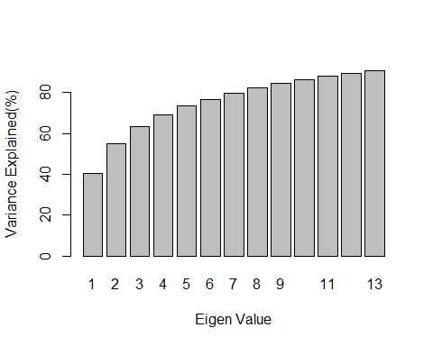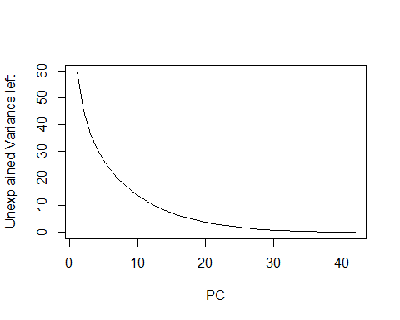

## Variance Explained by each PC:

## [1] 40.37951 55.06583 63.27942 69.01020 73.35337 76.86673 79.81644  
## [8] 82.31522 84.47580 86.36093 88.00024 89.43032 90.69373 91.81132  
## [15] 92.79188 93.67214 94.44983 95.14420 95.76474 96.31406 96.80449  
## [22] 97.23933 97.62621 97.96660 98.26732 98.53361 98.76581 98.96908  
## [29] 99.14691 99.30290 99.43834 99.55328 99.65203 99.73419 99.80303  
## [36] 99.85890 99.90415 99.94004 99.96677 99.98357 99.99433 100.00000

## quartersList X1 X2 X3 X4 X5 X6 X7  
## 1 1986-01-01 24.29628 43.89452 50.78251 56.35344 61.62106 65.95397 69.80198  
## 2 1986-04-01 20.97506 37.34170 46.43886 53.57118 59.51706 64.65303 69.20536  
## 3 1986-07-01 18.73147 35.26181 44.92363 53.40469 59.34766 64.58570 68.99877  
## 4 1986-10-01 29.29835 40.34408 48.55883 55.11240 60.62791 65.77959 70.36455  
## 5 1987-01-01 28.88576 46.86070 53.93755 59.49473 64.58999 68.90521 72.76518  
## 6 1987-04-01 55.45405 65.25604 70.76623 74.53535 78.06575 80.54390 82.70032  
## 7 1987-07-01 43.46815 53.57182 59.26810 64.21716 68.56065 72.40405 75.82994  
## 8 1987-10-01 44.30748 60.61289 68.28511 75.24110 79.98157 82.96730 85.60467  
## 9 1988-01-01 34.82027 52.67376 61.39089 66.77928 70.83298 74.08608 77.16815  
## 10 1988-04-01 21.65304 37.95869 48.51638 57.58770 64.85265 69.54072 73.32968  
## 11 1988-07-01 25.99073 47.91757 56.51708 62.60342 68.04888 72.25189 76.22793  
## 12 1988-10-01 27.98085 46.58217 60.02882 65.09594 69.47602 73.57194 76.71158  
## 13 1989-01-01 35.19104 51.48603 58.95345 65.51505 70.37611 74.26224 77.48278  
## 14 1989-04-01 38.01527 58.84854 74.64028 77.88450 81.07144 83.86516 86.17166  
## 15 1989-07-01 54.18845 77.04098 80.44047 82.71354 84.89624 86.64272 88.35884  
## 16 1989-10-01 45.55191 71.86980 76.59086 80.81159 83.65784 85.83053 87.62074  
## 17 1990-01-01 54.94544 69.00479 74.10778 77.95715 80.48900 82.75150 84.82533  
## 18 1990-04-01 44.15872 57.20029 66.50900 71.46360 75.40292 78.86148 81.71403  
## 19 1990-07-01 36.33621 55.98567 63.70869 69.57477 73.18124 76.26047 79.26042  
## 20 1990-10-01 34.70670 56.13334 62.95125 69.03711 74.19002 78.13081 81.25637  
## 21 1991-01-01 46.91055 71.06491 76.55149 79.96395 83.12095 85.69307 87.40825  
## 22 1991-04-01 39.33587 61.12095 68.90879 73.27132 76.84854 79.93585 82.52977  
## 23 1991-07-01 56.07890 76.48838 81.01705 84.32527 86.41805 88.22174 89.86618  
## 24 1991-10-01 38.85648 56.23819 62.81523 68.74465 74.00407 77.70197 80.14123  
## 25 1992-01-01 39.05336 63.12901 68.14044 72.56669 75.76019 78.64114 81.28907  
## 26 1992-04-01 38.43669 56.17266 67.92583 73.62909 77.21133 80.07854 82.76480  
## 27 1992-07-01 32.01276 51.01915 59.89854 67.49578 72.53681 76.76654 80.02102  
## 28 1992-10-01 25.17563 45.72536 55.10788 62.97919 69.10616 74.02760 77.83775  
## 29 1993-01-01 31.79752 50.40401 57.09518 62.63410 67.60258 71.34891 74.71564  
## 30 1993-04-01 27.08961 49.23811 56.37664 62.31614 67.25956 71.82052 75.24149  
## 31 1993-07-01 30.19930 53.06163 61.23177 65.76210 69.64903 73.05437 76.17929  
## 32 1993-10-01 29.58136 48.42362 56.68966 63.18868 68.36747 72.52561 76.07700  
## 33 1994-01-01 30.36414 53.03525 64.05340 68.86252 72.85125 76.14069 79.24883  
## 34 1994-04-01 41.72696 52.89203 61.74008 66.99719 71.89575 75.84134 79.16685  
## 35 1994-07-01 28.97440 47.85304 56.27598 63.01196 67.96885 71.67097 74.79837  
## 36 1994-10-01 27.59407 49.87839 58.99536 65.06334 69.04685 72.14877 75.04013  
## 37 1995-01-01 51.52238 63.28490 71.67914 77.26994 80.10480 82.66351 84.74529  
## 38 1995-04-01 31.80830 50.59486 59.29828 64.34405 68.82874 72.98069 76.61621  
## 39 1995-07-01 27.36855 45.19503 56.24975 62.25421 66.81962 70.49644 73.92093  
## 40 1995-10-01 22.21112 36.68931 47.38348 54.68098 60.40418 64.74207 68.94741  
## 41 1996-01-01 24.68821 38.36890 49.71911 57.01740 62.63906 67.10453 71.14687  
## 42 1996-04-01 16.38645 28.83678 38.40929 47.21439 53.84138 59.74951 64.72224  
## 43 1996-07-01 30.00864 42.65346 51.87890 59.05168 65.17959 69.90889 73.23384  
## 44 1996-10-01 26.46375 39.70970 48.28829 54.92522 60.47078 64.72933 68.81923  
## 45 1997-01-01 22.53980 36.21988 47.89138 54.42080 60.22036 65.09214 69.05848  
## 46 1997-04-01 28.16301 37.71448 46.01690 53.48601 59.28281 64.22023 68.62099  
## 47 1997-07-01 27.57848 45.41207 57.78560 65.34141 71.83444 76.00583 79.17571  
## 48 1997-10-01 41.06563 64.67314 76.36515 84.67630 87.38752 89.59802 91.43986  
## 49 1998-01-01 40.70923 64.67794 76.06473 81.73796 84.92225 87.28756 89.23142  
## 50 1998-04-01 38.93741 56.47001 65.18659 72.50756 76.52501 79.88858 82.40281  
## 51 1998-07-01 36.16242 57.83714 66.56415 72.38015 77.37546 80.89568 83.63578  
## 52 1998-10-01 31.32257 48.50163 60.06047 67.38257 73.44541 77.70141 80.73809  
## 53 1999-01-01 36.18299 51.75102 60.89738 68.14628 73.50181 76.95032 79.95864  
## 54 1999-04-01 21.49447 36.31070 48.40300 57.17018 64.08010 68.97165 72.58980  
## 55 1999-07-01 24.37540 37.30383 48.51272 58.58657 65.56187 70.10870 73.87660  
## 56 1999-10-01 27.02959 40.04000 50.25271 56.96200 61.39990 65.26271 68.76956  
## 57 2000-01-01 32.16146 46.41945 54.30886 59.72920 64.24478 68.00702 71.47340  
## 58 2000-04-01 36.00339 52.25074 61.56363 67.19539 71.55115 75.20504 78.02753  
## 59 2000-07-01 30.51956 50.32514 57.60726 63.32907 68.43670 72.47067 76.06964  
## 60 2000-10-01 34.99336 48.81368 60.00225 65.41632 70.19990 74.62234 77.66533  
## 61 2001-01-01 41.97686 54.44841 63.97207 69.60243 74.15452 77.90578 81.00012  
## 62 2001-04-01 28.55294 44.43242 56.73700 63.63668 69.82801 73.44811 77.03326  
## 63 2001-07-01 38.83286 58.20519 67.04246 72.96860 76.83627 79.84244 82.34229  
## 64 2001-10-01 29.68205 44.09814 55.11624 63.70962 68.84159 73.83635 77.05443  
## 65 2002-01-01 27.98025 40.77915 50.69885 57.25558 62.90119 67.59863 71.71330  
## 66 2002-04-01 29.95948 44.85598 55.58903 63.77470 68.35458 72.51319 75.58951  
## 67 2002-07-01 48.44868 61.56544 72.22665 76.70284 80.12773 82.97301 85.14110  
## 68 2002-10-01 44.72974 57.29405 67.41289 73.46090 76.95196 79.63876 82.11464  
## 69 2003-01-01 43.06429 55.28532 63.80034 70.10735 74.80869 78.04065 80.53762  
## 70 2003-04-01 31.75830 46.65104 56.06995 63.76074 68.49331 72.63892 75.62128  
## 71 2003-07-01 22.16811 40.73099 49.95710 57.60427 62.94671 66.97515 70.57803  
## 72 2003-10-01 27.15648 51.07106 63.37801 70.96300 75.08351 78.20752 81.03454  
## 73 2004-01-01 40.61643 55.36200 65.14508 71.34984 75.46265 79.03312 82.09324  
## 74 2004-04-01 45.55447 58.35010 65.81260 71.62701 76.02195 80.10098 82.83755  
## 75 2004-07-01 31.91114 44.03199 53.86988 61.29637 66.34805 70.68932 74.15136  
## 76 2004-10-01 35.29079 49.24668 57.70717 63.89338 68.39103 72.58670 76.02347  
## 77 2005-01-01 40.57291 50.39834 58.35561 64.48783 69.08306 73.18027 76.22147  
## 78 2005-04-01 37.50460 49.37128 59.64683 64.82944 68.76221 72.46970 75.80728  
## 79 2005-07-01 40.76777 51.84507 58.04197 63.94253 68.97545 73.62163 76.73304  
## 80 2005-10-01 30.68794 45.71390 58.62579 67.80232 73.09451 76.81776 80.17597  
## 81 2006-01-01 39.98355 50.68169 57.34532 63.28764 69.01186 73.64126 77.95627  
## 82 2006-04-01 58.80457 67.37576 74.64215 79.31449 82.93831 85.15111 87.25084  
## 83 2006-07-01 49.72598 60.20089 67.72728 73.67848 77.22683 80.13098 82.88335  
## 84 2006-10-01 32.58722 43.68828 52.98987 59.94309 64.51377 68.48805 72.34490  
## 85 2007-01-01 56.52395 66.41777 71.97731 76.45995 79.56911 82.30294 84.70853  
## 86 2007-04-01 41.67142 53.15609 61.79253 67.78570 72.13500 76.01974 79.31497  
## 87 2007-07-01 58.44660 74.04104 78.29018 82.20378 85.09254 87.17682 88.81576  
## 88 2007-10-01 47.21793 62.16444 69.30412 74.39082 78.21748 81.35246 84.21161  
## 89 2008-01-01 50.85195 67.65022 73.73752 77.72595 81.09811 83.86723 86.36963  
## 90 2008-04-01 33.41780 52.06216 60.99629 67.10232 71.97043 75.58509 78.94535  
## 91 2008-07-01 52.14352 71.03859 76.94293 80.26938 83.38686 86.07554 88.25441  
## 92 2008-10-01 57.68758 73.13274 79.01930 82.86721 85.44245 87.48196 89.41584  
## 93 2009-01-01 50.66163 68.62752 75.03895 78.86063 82.43564 85.10817 87.29796  
## 94 2009-04-01 47.19275 65.96941 72.97580 78.16467 81.64745 84.44103 86.42663  
## 95 2009-07-01 54.97034 67.20972 73.76370 78.35831 81.16528 83.73872 86.20528  
## 96 2009-10-01 58.03981 69.49773 75.77997 79.75150 82.35279 84.66790 86.78256  
## 97 2010-01-01 53.19111 64.94988 70.85991 75.31662 78.68967 81.11505 83.48277  
## 98 2010-04-01 70.48429 80.85649 84.88910 87.57640 89.89393 91.21696 92.18500  
## 99 2010-07-01 56.82165 68.25740 75.08935 79.22879 82.20052 84.70116 86.51878  
## 100 2010-10-01 56.69450 63.62269 69.39367 74.19029 77.44769 80.29992 82.57308  
## 101 2011-01-01 45.83323 58.80655 64.95705 70.46375 73.99233 77.08090 79.66367  
## 102 2011-04-01 64.29856 72.79346 77.62812 80.37569 82.86749 84.94182 86.93965  
## 103 2011-07-01 66.28287 78.18530 82.43764 85.34462 87.31849 89.16166 90.65330  
## 104 2011-10-01 68.01378 81.95234 84.80664 86.99262 88.71951 89.97980 91.12227  
## 105 2012-01-01 61.66648 68.98862 74.12783 78.29818 81.07857 83.35721 85.26762  
## 106 2012-04-01 65.03169 75.46728 78.74811 81.43171 83.98604 85.99334 87.64415  
## 107 2012-07-01 65.88615 73.39323 77.74501 81.25618 83.87541 86.12320 87.88997  
## 108 2012-10-01 53.97011 60.95840 66.32678 70.41987 73.92738 77.19604 79.82672  
## 109 2013-01-01 50.33104 58.22910 64.78334 69.76129 73.60552 76.65812 79.47281  
## 110 2013-04-01 49.21873 58.65611 64.76232 70.01818 74.05409 77.55478 80.33201  
## 111 2013-07-01 41.64071 50.18370 58.52093 64.79489 69.13939 73.19114 76.43598  
## 112 2013-10-01 45.03110 53.67595 61.66415 66.76870 70.77468 74.12854 77.36778  
## 113 2014-01-01 43.43305 56.54927 65.14454 69.81782 73.66170 76.90502 79.66713  
## 114 2014-04-01 33.04541 45.28817 54.60480 60.19657 65.15474 68.93752 72.43342  
## 115 2014-07-01 40.32410 53.47911 62.36107 66.87391 70.98973 74.35247 77.18541  
## 116 2014-10-01 39.21311 54.50943 64.54175 71.30448 75.77886 78.94434 81.72636  
## 117 2015-01-01 38.10920 48.59611 57.61128 65.18198 70.52700 74.69346 78.28155  
## 118 2015-04-01 45.68135 57.26756 64.47292 69.57226 74.06791 77.48642 80.52536  
## 119 2015-07-01 50.49958 62.54711 68.56517 73.55188 77.98409 81.06005 83.83723  
## 120 2015-10-01 39.16499 50.30863 60.56108 67.58149 73.44270 77.89876 81.16344  
## 121 2016-01-01 53.67687 64.21974 73.09047 77.16813 80.59420 83.56233 85.95582  
## 122 2016-04-01 71.82760 78.44429 82.11680 85.67701 87.80306 89.70427 90.92437  
## 123 2016-07-01 49.13593 57.90460 64.36457 69.60954 73.88085 77.59526 80.61824  
## 124 2016-10-01 35.48430 48.73803 58.45847 65.79550 70.95004 74.79580 77.88250  
## 125 2017-01-01 36.16946 49.65916 59.32173 66.20102 71.30792 75.81288 79.43477  
## 126 2017-04-01 37.90393 56.54614 65.43326 70.27000 74.52561 78.14131 80.92384  
## 127 2017-07-01 33.69933 46.83341 54.93593 60.67963 65.96145 70.51276 74.62470  
## 128 2017-10-01 28.75592 40.60354 50.23063 57.05667 63.24575 68.08505 72.25746  
## 129 2018-01-01 45.60609 56.59418 64.47770 69.54766 73.99457 77.97438 81.28041  
## 130 2018-04-01 41.50367 53.65182 61.24576 67.01541 72.24205 75.84703 78.51028  
## 131 2018-07-01 46.44411 57.79502 65.41158 70.61702 74.39782 77.20016 79.62503  
## 132 2018-10-01 42.94723 53.83836 62.42403 68.10843 73.24485 76.98873 80.18542  
## 133 2019-01-01 40.80056 53.71748 62.43080 68.53573 72.78048 76.69763 79.53341  
## 134 2019-04-01 37.44763 47.25715 55.08018 62.47358 68.35992 73.44735 77.30603  
## 135 2019-07-01 37.15236 48.70300 58.01048 65.57121 70.31039 74.27111 77.83209  
## 136 2019-10-01 40.29009 51.29088 59.61646 66.66706 71.71410 75.57493 79.30396  
## 137 2020-01-01 61.01042 77.51821 83.64546 87.85956 89.95225 91.97891 93.43805  
## 138 2020-04-01 59.66867 69.95404 75.60638 80.30604 83.95996 86.96528 89.24031  
## X8 X9 X10 X11 X12 X13  
## 1 73.21077 76.28321 78.78538 81.15650 83.42202 85.21650  
## 2 72.94170 76.33105 79.00977 81.43569 83.44701 85.32562  
## 3 72.96055 76.36205 79.18355 81.56518 83.78964 85.86613  
## 4 73.99483 77.21624 80.01281 82.43951 84.71250 86.71321  
## 5 76.49573 79.20627 81.86842 83.96672 85.78006 87.40639  
## 6 84.58038 86.28809 87.85851 89.31882 90.59031 91.69901  
## 7 78.56547 81.11692 83.12741 84.93565 86.64897 88.26436  
## 8 88.08334 89.84976 91.31722 92.58781 93.70768 94.57825  
## 9 80.16231 82.61404 84.65962 86.41174 87.98422 89.49812  
## 10 76.58844 79.36023 81.75205 83.84289 85.75210 87.39152  
## 11 79.40602 81.96383 84.06979 86.09221 87.56690 88.98246  
## 12 79.47770 81.82044 84.05762 86.08054 87.96722 89.49816  
## 13 80.61668 83.01768 85.05312 86.80303 88.29772 89.58644  
## 14 87.99115 89.55016 90.86004 92.00174 92.99413 93.92093  
## 15 89.86933 91.21356 92.26193 93.21039 94.00055 94.66761  
## 16 89.21486 90.65962 92.05398 93.07290 93.97836 94.71895  
## 17 86.69624 88.49078 89.91930 91.21225 92.26393 93.16950  
## 18 84.26525 86.26231 88.04351 89.47470 90.59153 91.68497  
## 19 82.00504 84.04897 85.93335 87.72174 89.42560 90.86911  
## 20 83.42965 85.54187 87.47819 89.13115 90.46884 91.73149  
## 21 88.97104 90.26225 91.40000 92.38790 93.26749 94.07109  
## 22 84.76008 86.66937 88.22923 89.63686 90.78962 91.88495  
## 23 91.12817 92.28532 93.30498 94.26083 94.94052 95.56283  
## 24 82.24554 84.14228 85.89558 87.48220 88.99945 90.30825  
## 25 83.72332 86.11696 88.03269 89.42489 90.61469 91.65190  
## 26 84.94309 86.67973 88.30642 89.84098 91.11704 92.13367  
## 27 82.77602 85.18389 87.34733 89.09413 90.47949 91.68263  
## 28 81.08249 83.38350 85.35201 87.11732 88.76538 90.10970  
## 29 77.51958 79.86089 82.08864 83.95170 85.70439 87.24150  
## 30 78.08236 80.56473 82.84352 84.96685 86.61491 88.11833  
## 31 78.53800 80.79680 83.01063 84.94903 86.70853 88.44295  
## 32 78.98578 81.66909 84.02882 86.16476 87.76567 89.25906  
## 33 82.10418 84.37373 86.61309 88.45584 89.87728 91.23718  
## 34 82.18888 84.23079 86.07994 87.73475 89.12977 90.32250  
## 35 77.43818 79.94715 82.17336 84.17893 86.16295 87.59921  
## 36 77.77707 80.01000 82.03851 83.89549 85.64540 87.24373  
## 37 86.56597 88.17792 89.70302 91.10052 92.29343 93.39862  
## 38 79.45695 81.85026 83.97093 85.83284 87.48390 88.91626  
## 39 76.89627 79.50817 81.66278 83.60788 85.43856 87.08375  
## 40 72.59244 76.03461 79.14999 81.49396 83.54654 85.40356  
## 41 74.67849 77.58617 80.01445 82.26635 84.34099 85.86692  
## 42 68.79160 72.43570 75.57111 78.25181 80.59198 82.77519  
## 43 76.39141 78.80533 81.13655 83.34094 85.02763 86.63565  
## 44 72.28439 75.60219 78.63065 81.04630 83.16691 85.01686  
## 45 72.47816 75.47895 78.32702 80.84022 82.94855 84.98282  
## 46 72.45365 76.00636 79.03095 81.29431 83.39614 85.14615  
## 47 82.11081 84.79080 86.91640 88.58889 89.84192 90.81209  
## 48 92.61844 93.66497 94.62749 95.40785 95.95146 96.42512  
## 49 91.15693 92.29004 93.35296 94.15710 94.79677 95.37890  
## 50 84.88080 87.03464 88.92112 90.30795 91.45022 92.51397  
## 51 85.85824 87.93847 89.76858 91.35419 92.71174 93.63330  
## 52 83.49326 85.49790 87.22204 88.81163 90.20068 91.40964  
## 53 82.62913 85.00024 86.99557 88.54384 89.95674 91.09309  
## 54 75.61388 78.38620 80.78070 82.86659 84.82352 86.66455  
## 55 77.36661 80.26849 82.67668 84.78641 86.53348 88.15269  
## 56 71.87008 74.65462 77.23390 79.72001 81.94668 83.84009  
## 57 74.72505 77.49029 80.01571 82.31957 84.26362 86.07504  
## 58 80.56270 82.70045 84.64763 86.49854 88.08545 89.57298  
## 59 79.06399 81.34504 83.47702 85.29933 86.95704 88.29442  
## 60 80.31351 82.64325 84.80844 86.73172 88.24900 89.68268  
## 61 83.43698 85.56533 87.03141 88.48210 89.86476 91.03862  
## 62 79.86723 82.54378 85.03275 86.85757 88.52554 89.73794  
## 63 84.61849 86.83782 88.53499 89.93792 91.14002 92.14230  
## 64 79.67580 81.84151 83.92317 85.77861 87.56751 89.10126  
## 65 75.28638 78.34716 80.90237 83.36216 85.42687 87.30123  
## 66 78.35958 80.94001 83.21806 85.22889 86.97326 88.58042  
## 67 86.87227 88.29621 89.50905 90.56779 91.57266 92.46526  
## 68 84.07544 85.89814 87.59532 89.08409 90.19534 91.27179  
## 69 82.87474 84.79706 86.62218 88.17016 89.53832 90.77441  
## 70 78.28004 80.66442 82.82264 84.72203 86.42045 87.99104  
## 71 73.78749 76.73984 79.27631 81.48188 83.51925 85.37097  
## 72 83.27146 85.29427 86.92682 88.44541 89.80526 91.06323  
## 73 84.50239 86.31021 88.00283 89.44021 90.79265 91.96178  
## 74 85.26240 87.31498 89.05084 90.50262 91.74440 92.86083  
## 75 77.24186 79.80323 82.14900 84.39652 86.37252 87.93300  
## 76 78.82239 81.44799 84.05818 86.11671 87.90616 89.53634  
## 77 79.12821 81.90852 84.12155 86.17202 87.73737 89.18931  
## 78 78.63877 81.29727 83.39088 85.24398 86.91951 88.50809  
## 79 79.39494 81.96898 84.24502 86.08402 87.76838 89.18518  
## 80 82.85909 85.24185 87.52654 89.21253 90.82297 92.13221  
## 81 81.04130 83.77158 86.07150 88.06612 89.78398 91.35987  
## 82 88.99488 90.51203 91.72384 92.84945 93.70524 94.54640  
## 83 85.16649 87.11202 88.65528 90.10391 91.44799 92.50110  
## 84 75.68986 78.50766 81.09848 83.56363 85.72729 87.84616  
## 85 86.85218 88.54772 90.22829 91.55416 92.65194 93.61507  
## 86 81.85025 83.99706 85.74905 87.44290 88.97374 90.40874  
## 87 90.32638 91.56810 92.58768 93.42950 94.20536 94.93942  
## 88 86.21250 88.05963 89.54590 90.98989 92.29203 93.30748  
## 89 88.21088 89.82479 91.34335 92.64814 93.61739 94.41681  
## 90 81.43169 83.63276 85.67573 87.24804 88.75134 90.21803  
## 91 90.15665 91.58245 92.83328 93.91012 94.83228 95.58473  
## 92 90.97095 92.16787 93.24300 94.09452 94.84035 95.52406  
## 93 88.86124 90.34490 91.46636 92.49078 93.40058 94.17046  
## 94 88.14995 89.77879 91.08483 92.23218 93.17467 94.02868  
## 95 87.71602 89.11659 90.40814 91.64942 92.56158 93.43128  
## 96 88.49406 90.06714 91.35129 92.49156 93.41075 94.23426  
## 97 85.67221 87.44333 88.92441 90.24917 91.44904 92.55991  
## 98 93.04671 93.82995 94.56800 95.20645 95.74399 96.24502  
## 99 88.14050 89.73998 90.99448 92.23164 93.16357 94.02508  
## 100 84.54276 86.37128 88.00975 89.46175 90.73003 91.84374  
## 101 82.01795 84.07769 85.95603 87.75543 89.14057 90.47580  
## 102 88.46494 89.81985 90.99523 91.95683 92.85795 93.62900  
## 103 91.85516 92.93951 93.72107 94.45598 95.04441 95.62649  
## 104 92.09530 92.99906 93.77698 94.52259 95.19436 95.78907  
## 105 86.97239 88.44255 89.78491 91.01525 92.01335 92.89903  
## 106 89.19975 90.54053 91.73377 92.60910 93.44214 94.16988  
## 107 89.38647 90.65026 91.78494 92.70488 93.54664 94.30679  
## 108 82.23856 84.34422 86.18350 87.90643 89.31715 90.51866  
## 109 82.03755 84.36585 86.27482 87.90325 89.28024 90.59865  
## 110 82.81263 84.97846 86.64271 88.09555 89.48874 90.74933  
## 111 79.07172 81.59238 83.72091 85.65710 87.31969 88.80850  
## 112 80.24084 82.72536 84.89825 86.65679 88.31741 89.63665  
## 113 82.27099 84.18356 85.94643 87.46086 88.84873 90.10461  
## 114 75.73638 78.74411 81.29752 83.59195 85.67638 87.54187  
## 115 79.96717 82.32554 84.55254 86.27066 87.91584 89.37688  
## 116 84.00901 86.03541 87.94365 89.42698 90.70005 91.84229  
## 117 80.89989 83.27403 85.21544 87.04779 88.61462 89.97219  
## 118 82.94180 85.04446 86.69621 88.19610 89.62892 90.89481  
## 119 86.10253 88.25040 89.81200 91.16909 92.28716 93.31222  
## 120 84.02873 86.02244 87.75227 89.17823 90.50844 91.71739  
## 121 88.04582 89.71089 91.03803 92.12896 92.99082 93.80458  
## 122 92.04117 93.11463 94.03697 94.73766 95.37268 95.92288  
## 123 83.02434 85.29944 87.29730 88.91192 90.35529 91.58047  
## 124 80.44539 82.85378 85.05274 87.06804 88.71381 90.05648  
## 125 82.23548 84.47572 86.37042 87.84786 89.29929 90.64501  
## 126 83.11118 84.95119 86.63621 88.01899 89.33141 90.53316  
## 127 77.47044 79.96395 82.01665 83.97186 85.71365 87.22487  
## 128 75.42506 78.28848 80.78358 83.14303 85.12081 86.99221  
## 129 83.61289 85.66881 87.37805 88.77613 90.10673 91.40645  
## 130 81.03396 83.32330 85.27153 86.88250 88.34996 89.65940  
## 131 81.91193 83.94067 85.75669 87.43617 89.04712 90.26153  
## 132 83.07690 85.20415 87.24560 88.95250 90.30659 91.47072  
## 133 82.10124 84.22849 86.26187 88.04139 89.64255 90.92073  
## 134 80.14739 82.77744 85.21921 87.26572 88.93137 90.39698  
## 135 80.97186 83.24928 85.23081 86.92628 88.58065 89.91235  
## 136 81.83316 84.19542 86.00613 87.78395 89.22025 90.49398  
## 137 94.48977 95.44604 96.18653 96.88359 97.35732 97.75708  
## 138 90.71699 92.01444 93.13564 94.00228 94.74940 95.34146

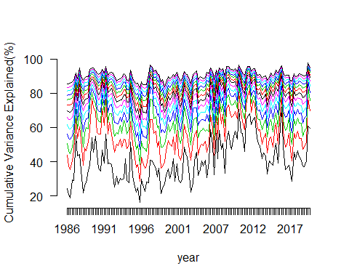

Appendix Fig 2

# Regressions using the PC global factors

* Train year is selected as the previous year to which we are doing regression for
* Only countries which have a valid return in both the training period and test period are used in the dataset to avoid cases like Columbia which has valid 15 days of returns in some quarters and less than 15 days of returns in the consecutive year. If the country doesn’t qualify these conditions, then r square is not considered for the firm for the testing year.
* If the country was present before 1986, then the PC are constructed by removing that firm from the equation while we do OLS for that firm, otherwise all the pre86 firms are used to construct the PC.
* Regression are run for each country, each year and the resulting $adjustedR^{2}$ is recorded.
* For running the regression, we get the eigen vectors of the train year’s returns covariance matrix and then it with the returns matrix of the subsequent year which contains the daily returns time series for each country to get the factor loadings. This becomes our explanatory variables. The dependent variable is the daily return for each country.
* So this regression is run for each country’s return time series.

## integer(0)

## quartersList eq  
## 1 1986-01-01 76.10667  
## 2 1986-04-01 79.30656  
## 3 1986-07-01 74.70013  
## 4 1986-10-01 79.55741  
## 5 1987-01-01 75.16641  
## 6 1987-04-01 75.82912  
## 7 1987-07-01 81.59208  
## 8 1987-10-01 42.52936  
## 9 1988-01-01 63.28582  
## 10 1988-04-01 71.76768  
## 11 1988-07-01 63.90605  
## 12 1988-10-01 73.42235  
## 13 1989-01-01 70.91442  
## 14 1989-04-01 61.28516  
## 15 1989-07-01 61.19421  
## 16 1989-10-01 59.10183  
## 17 1990-01-01 69.19108  
## 18 1990-04-01 79.76251  
## 19 1990-07-01 63.33632  
## 20 1990-10-01 64.88727  
## 21 1991-01-01 58.09032  
## 22 1991-04-01 60.89515  
## 23 1991-07-01 52.38998  
## 24 1991-10-01 76.33561  
## 25 1992-01-01 65.81405  
## 26 1992-04-01 72.45195  
## 27 1992-07-01 68.33238  
## 28 1992-10-01 76.16154  
## 29 1993-01-01 77.66972  
## 30 1993-04-01 77.79892  
## 31 1993-07-01 74.23722  
## 32 1993-10-01 78.54520  
## 33 1994-01-01 71.89634  
## 34 1994-04-01 75.50901  
## 35 1994-07-01 78.15177  
## 36 1994-10-01 74.65815  
## 37 1995-01-01 73.19533  
## 38 1995-04-01 71.17354  
## 39 1995-07-01 76.91919  
## 40 1995-10-01 82.50976  
## 41 1996-01-01 78.75371  
## 42 1996-04-01 88.76185  
## 43 1996-07-01 75.01058  
## 44 1996-10-01 78.25407  
## 45 1997-01-01 81.79824  
## 46 1997-04-01 77.19534  
## 47 1997-07-01 73.87836  
## 48 1997-10-01 61.04192  
## 49 1998-01-01 68.35857  
## 50 1998-04-01 70.45628  
## 51 1998-07-01 63.55361  
## 52 1998-10-01 69.78546  
## 53 1999-01-01 73.25253  
## 54 1999-04-01 81.14302  
## 55 1999-07-01 77.07033  
## 56 1999-10-01 77.99402  
## 57 2000-01-01 75.19921  
## 58 2000-04-01 65.56414  
## 59 2000-07-01 75.32462  
## 60 2000-10-01 70.03526  
## 61 2001-01-01 70.35966  
## 62 2001-04-01 75.43464  
## 63 2001-07-01 65.97857  
## 64 2001-10-01 75.63875  
## 65 2002-01-01 78.36164  
## 66 2002-04-01 77.18134  
## 67 2002-07-01 66.31133  
## 68 2002-10-01 76.14695  
## 69 2003-01-01 72.11212  
## 70 2003-04-01 72.01431  
## 71 2003-07-01 77.14611  
## 72 2003-10-01 74.07694  
## 73 2004-01-01 69.13098  
## 74 2004-04-01 64.04175  
## 75 2004-07-01 72.79975  
## 76 2004-10-01 70.51060  
## 77 2005-01-01 69.88902  
## 78 2005-04-01 72.01613  
## 79 2005-07-01 71.11221  
## 80 2005-10-01 70.56384  
## 81 2006-01-01 71.07491  
## 82 2006-04-01 59.51661  
## 83 2006-07-01 64.16272  
## 84 2006-10-01 72.61828  
## 85 2007-01-01 59.85002  
## 86 2007-04-01 69.44042  
## 87 2007-07-01 54.19361  
## 88 2007-10-01 62.41895  
## 89 2008-01-01 52.83870  
## 90 2008-04-01 67.68156  
## 91 2008-07-01 55.39770  
## 92 2008-10-01 46.65673  
## 93 2009-01-01 56.61046  
## 94 2009-04-01 59.77712  
## 95 2009-07-01 56.76418  
## 96 2009-10-01 59.85911  
## 97 2010-01-01 61.20651  
## 98 2010-04-01 45.57139  
## 99 2010-07-01 55.76285  
## 100 2010-10-01 59.98113  
## 101 2011-01-01 65.57972  
## 102 2011-04-01 58.21484  
## 103 2011-07-01 50.63240  
## 104 2011-10-01 52.14598  
## 105 2012-01-01 60.35792  
## 106 2012-04-01 58.81473  
## 107 2012-07-01 57.35822  
## 108 2012-10-01 73.40645  
## 109 2013-01-01 69.50844  
## 110 2013-04-01 67.40185  
## 111 2013-07-01 66.34190  
## 112 2013-10-01 72.42003  
## 113 2014-01-01 67.79681  
## 114 2014-04-01 80.48827  
## 115 2014-07-01 75.85590  
## 116 2014-10-01 65.29782  
## 117 2015-01-01 68.07199  
## 118 2015-04-01 63.31914  
## 119 2015-07-01 56.95779  
## 120 2015-10-01 66.98102  
## 121 2016-01-01 53.74584  
## 122 2016-04-01 53.18496  
## 123 2016-07-01 66.71666  
## 124 2016-10-01 68.59339  
## 125 2017-01-01 65.59854  
## 126 2017-04-01 71.60965  
## 127 2017-07-01 73.95351  
## 128 2017-10-01 80.72978  
## 129 2018-01-01 62.23265  
## 130 2018-04-01 70.31868  
## 131 2018-07-01 68.66106  
## 132 2018-10-01 67.08850  
## 133 2019-01-01 70.55181  
## 134 2019-04-01 73.11976  
## 135 2019-07-01 72.33291  
## 136 2019-10-01 76.18630  
## 137 2020-01-01 35.21131  
## 138 2020-04-01 57.74878

## integer(0)

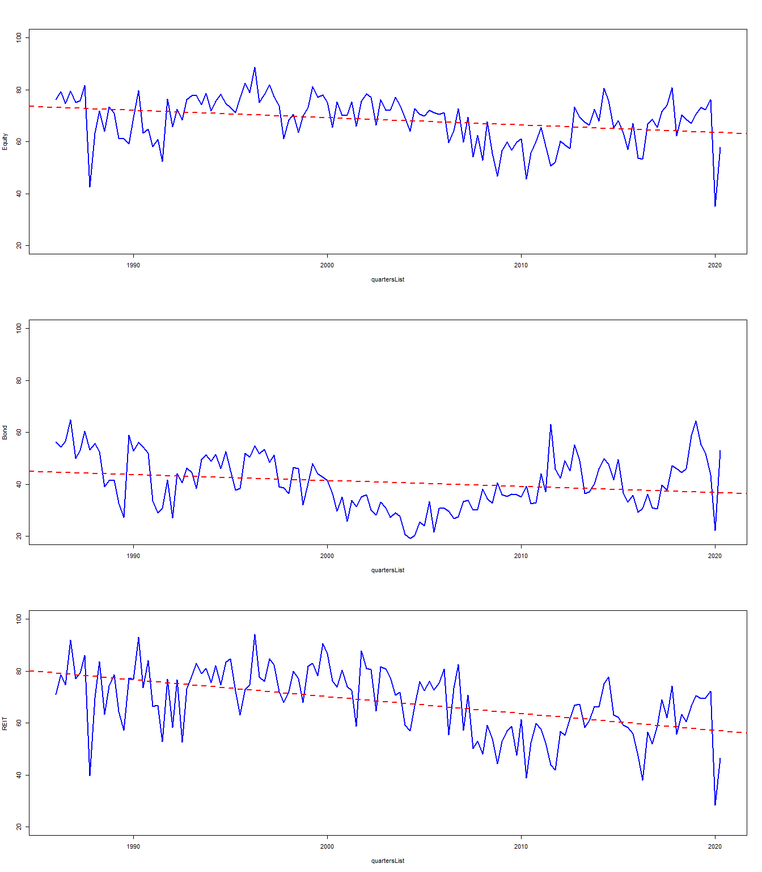

Fig 1

## integer(0)

This plot is the simple average of all the assets

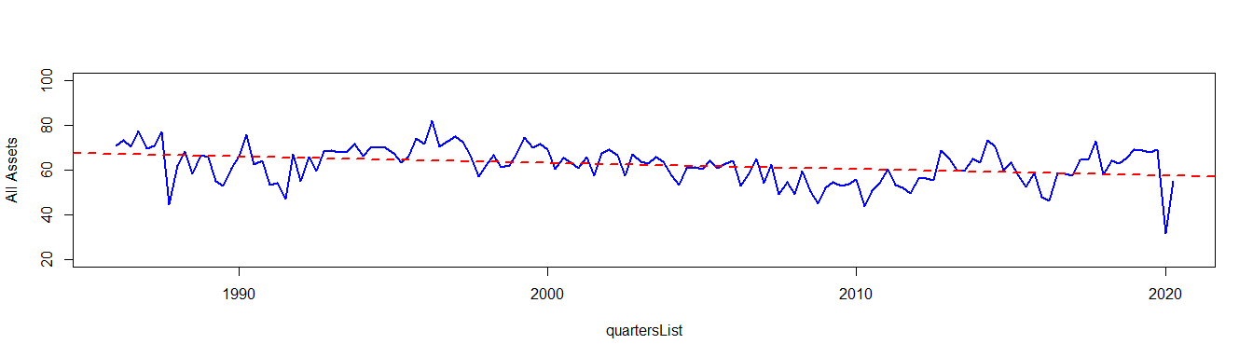

Fig 2

## integer(0)

The recent spike in the diversification index might be explained by relative difference in cases and thus economy.

# Bringing risk into the picture

* it’s the average daily standard deviation quaterly
* first table is diverisification and second is sd

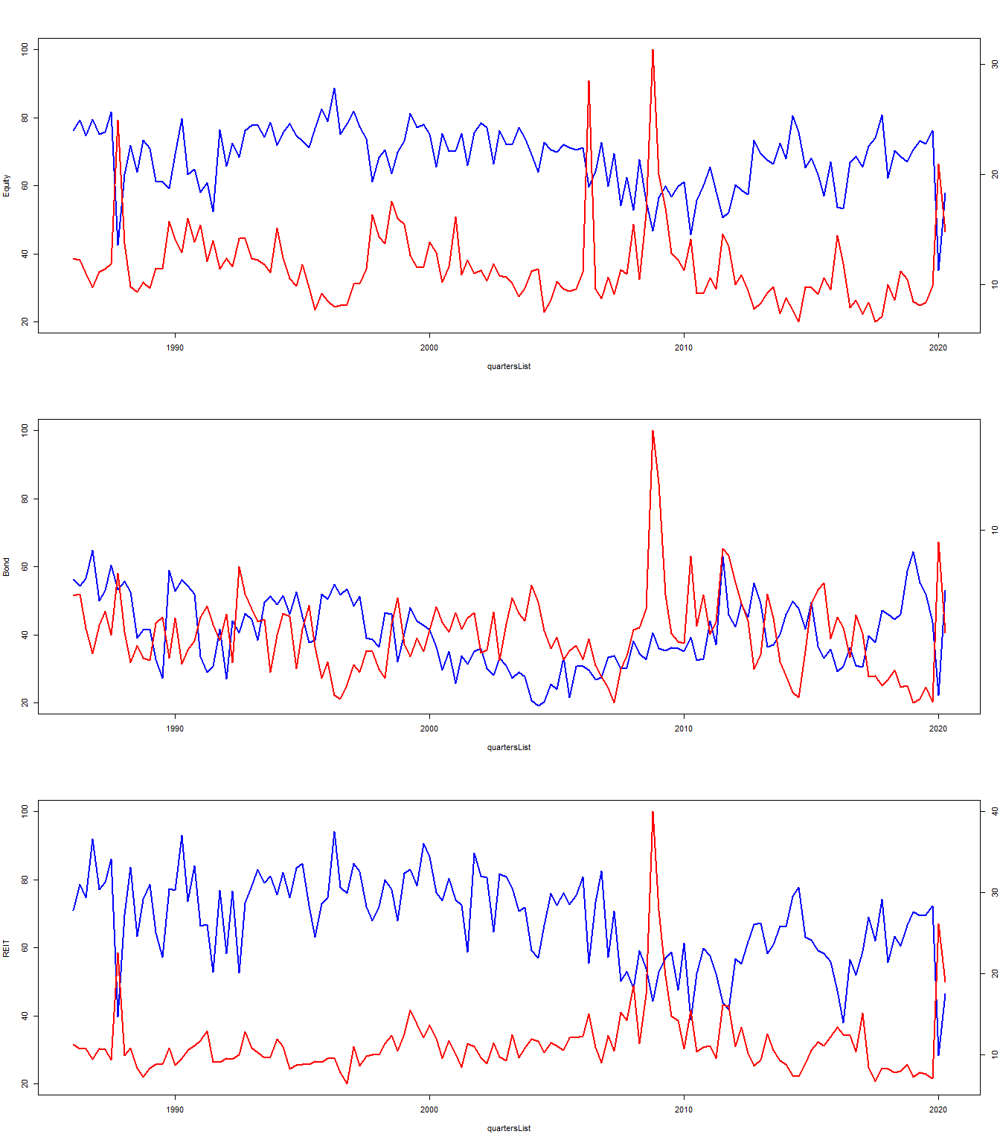

Fig 4

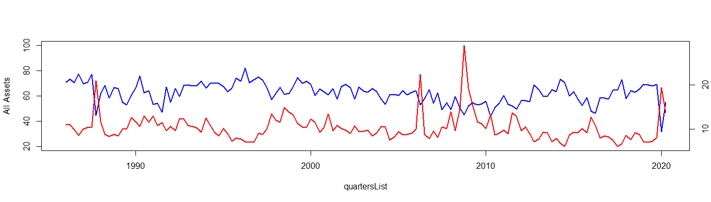

Fig 5

## Correlations

Equity Correlation with risk

cor.rowMeans.count_sd…grep…eq_…countries….na.rm…TRUE….

-0.524

Bond Correlation with risk

cor.rowMeans.count_sd…grep…bd_…countries….na.rm…TRUE….

-0.231

REIT Correlation with risk

cor.rowMeans.count_sd…grep…rt_…countries….na.rm…TRUE….

-0.493

All Assets Correlation with risk

cor.rowMeans.count_sd..na.rm…TRUE….100…sqrt.64….rowMeans.1…

-0.524

# Seeing NBER

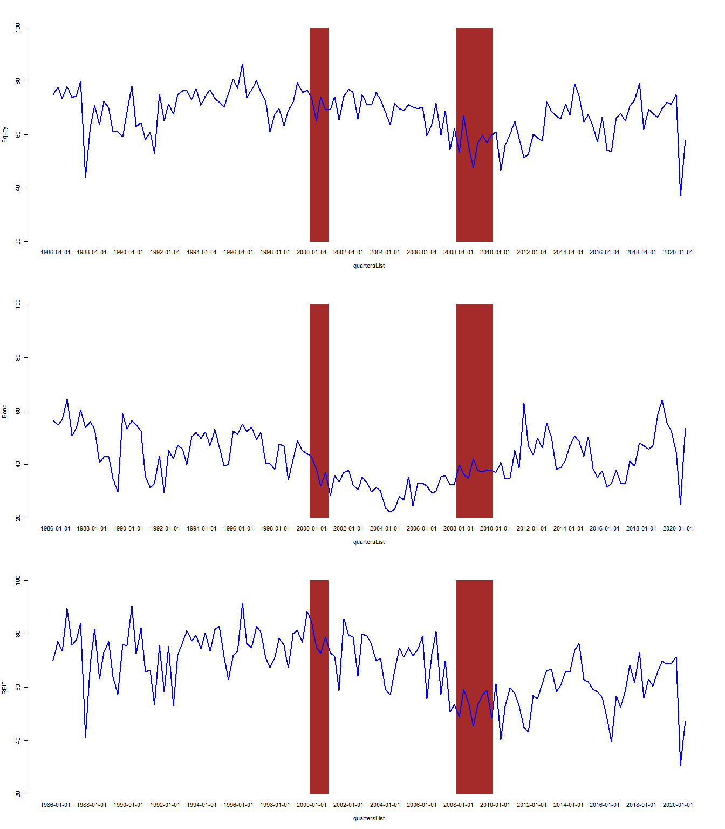

Appendix Fig 3

# Table 2

* There should be a return for at least 2 quarters to have a non NA value.
* OLS is applied with $1−R^{2}$ as the dependent and quarters as the explanatory variable. The slope and the tsat of the slope are recorded and stored.

## All time periods

Time Trends for Diversification Indexes for Equities, Bonds and REITs (continued below)

|  |  |  |  |  |  |
| --- | --- | --- | --- | --- | --- |
| eq_argentina | eq_australia | eq_austria | eq_bahrain | eq_bangladesh | eq_belgium |
| -0.1708 | -0.272 | -0.2626 | -0.006503 | -0.07425 | -0.2084 |
| -2.457 | -5.665 | -7.444 | -0.07779 | -0.4632 | -4.52 |

Table continues below

|  |  |  |  |  |  |
| --- | --- | --- | --- | --- | --- |
| eq_bosnia.and.herzegovina | eq_botswana | eq_brazil | eq_bulgaria | eq_cambodia | eq_canada |
| 0.409 | -0.5146 | -0.3533 | -0.2121 | 0.08403 | -0.314 |
| 2.008 | -7.229 | -6.905 | -1.8 | 0.2553 | -6.242 |

Table continues below

|  |  |  |  |  |  |  |
| --- | --- | --- | --- | --- | --- | --- |
| eq_chad | eq_chile | eq_china | eq_colombia | eq_côte.d.ivoire | eq_croatia | eq_cyprus |
| 0.01886 | -0.3977 | -0.1427 | 0.0222 | 0.2403 | -0.3489 | 0.1215 |
| 0.1045 | -10.52 | -2.942 | 0.1665 | 2.909 | -4.161 | 0.6419 |

Table continues below

|  |  |  |  |  |  |
| --- | --- | --- | --- | --- | --- |
| eq_czech.republic | eq_denmark | eq_ecuador | eq_egypt | eq_estonia | eq_finland |
| -0.4195 | -0.1082 | 0.02819 | -0.05354 | -0.2445 | -0.4006 |
| -5.272 | -2.374 | 0.5481 | -1.131 | -3.267 | -8.628 |

Table continues below

|  |  |  |  |  |  |  |
| --- | --- | --- | --- | --- | --- | --- |
| eq_france | eq_georgia | eq_germany | eq_ghana | eq_greece | eq_hong.kong | eq_hungary |
| -0.4088 | -0.3697 | -0.3428 | 0.02201 | -0.173 | -0.2148 | -0.2896 |
| -9.808 | -1.405 | -7.178 | 0.5329 | -3.134 | -4.893 | -4.666 |

Table continues below

|  |  |  |  |  |  |  |
| --- | --- | --- | --- | --- | --- | --- |
| eq_iceland | eq_india | eq_indonesia | eq_iraq | eq_ireland | eq_israel | eq_italy |
| -0.06768 | -0.3065 | -0.2647 | -0.3083 | -0.1921 | -0.3018 | -0.476 |
| -1.041 | -6.151 | -5.026 | -1.374 | -3.921 | -7.612 | -9.456 |

Table continues below

|  |  |  |  |  |  |  |
| --- | --- | --- | --- | --- | --- | --- |
| eq_jamaica | eq_japan | eq_jordan | eq_kazakhstan | eq_kenya | eq_kuwait | eq_latvia |
| 0.0009493 | -0.1227 | 0.1277 | 0.4371 | -0.01501 | -0.3246 | 0.158 |
| 0.02381 | -2.747 | 2.989 | 2.127 | -0.4787 | -5.517 | 0.6831 |

Table continues below

|  |  |  |  |  |  |
| --- | --- | --- | --- | --- | --- |
| eq_lebanon | eq_lithuania | eq_luxembourg | eq_macedonia | eq_malaysia | eq_malta |
| 0.1728 | 0.3786 | -0.06617 | -0.3415 | -0.05298 | 0.1263 |
| 1.167 | 1.441 | -0.9409 | -2.407 | -1.061 | 1.232 |

Table continues below

|  |  |  |  |  |  |
| --- | --- | --- | --- | --- | --- |
| eq_mauritius | eq_mexico | eq_montenegro | eq_morocco | eq_namibia | eq_netherlands |
| -0.1363 | -0.3551 | -0.3176 | -0.02905 | -0.3668 | -0.2502 |
| -2.716 | -5.815 | -2.342 | -0.5512 | -3.307 | -8.036 |

Table continues below

|  |  |  |  |  |  |  |
| --- | --- | --- | --- | --- | --- | --- |
| eq_new.zealand | eq_nigeria | eq_norway | eq_oman | eq_pakistan | eq_panama | eq_peru |
| -0.1549 | -0.0244 | -0.3012 | -0.05484 | 0.05994 | 0.103 | -0.3304 |
| -2.931 | -0.6088 | -6.363 | -0.9906 | 1.123 | 2.488 | -7.153 |

Table continues below

|  |  |  |  |  |  |
| --- | --- | --- | --- | --- | --- |
| eq_philippines | eq_poland | eq_portugal | eq_qatar | eq_romania | eq_russia |
| -0.1833 | -0.5112 | -0.008175 | -0.1668 | -0.548 | -0.4101 |
| -4.372 | -7.186 | -0.09671 | -2.776 | -5.202 | -5.047 |

Table continues below

|  |  |  |  |  |  |
| --- | --- | --- | --- | --- | --- |
| eq_saudi.arabia | eq_serbia | eq_singapore | eq_slovakia | eq_slovenia | eq_south.africa |
| -0.2477 | -0.04138 | -0.09374 | -0.06414 | -0.6343 | -0.3696 |
| -4.15 | -0.1616 | -2.157 | -1.32 | -4.577 | -8.515 |

Table continues below

|  |  |  |  |  |  |
| --- | --- | --- | --- | --- | --- |
| eq_south.korea | eq_spain | eq_sri.lanka | eq_sweden | eq_switzerland | eq_thailand |
| -0.4363 | -0.4008 | 0.05677 | -0.3641 | -0.1225 | -0.1277 |
| -9.567 | -8.15 | 2.302 | -8.585 | -3.144 | -2.64 |

Table continues below

|  |  |  |  |  |
| --- | --- | --- | --- | --- |
| eq_trinidad.and.tobago | eq_tunisia | eq_turkey | eq_uganda | eq_ukraine |
| 0.04293 | 0.194 | -0.3558 | -0.03577 | -0.5153 |
| 1.24 | 2.561 | -6.805 | -0.5247 | -7.122 |

Table continues below

|  |  |  |  |  |  |
| --- | --- | --- | --- | --- | --- |
| eq_united.arab.emirates | eq_uk | eq_us | eq_venezuela | eq_vietnam | eq_zambia |
| -0.201 | -0.348 | -0.3579 | 0.1241 | -0.1856 | -0.003938 |
| -1.255 | -8.836 | -6.871 | 2.938 | -1.047 | -0.1045 |

Table continues below

|  |  |  |  |  |  |  |
| --- | --- | --- | --- | --- | --- | --- |
| eq_zimbabwe | bd_australia | bd_austria | bd_belgium | bd_canada | bd_china | bd_czech.rep. |
| 0.0751 | -0.09878 | -0.07117 | -0.07673 | -0.3066 | -0.288 | 0.1285 |
| 0.5676 | -2.522 | -1.818 | -1.581 | -8.759 | -3.202 | 1.35 |

Table continues below

|  |  |  |  |  |  |  |
| --- | --- | --- | --- | --- | --- | --- |
| bd_denmark | bd_finland | bd_france | bd_germany | bd_greece | bd_hungary | bd_india |
| -0.04356 | -0.2896 | -0.1234 | -0.02266 | 1.071 | -0.2205 | 0.1874 |
| -1.014 | -3.934 | -2.868 | -0.582 | 11.44 | -2.259 | 1.475 |

Table continues below

|  |  |  |  |  |  |  |
| --- | --- | --- | --- | --- | --- | --- |
| bd_italy | bd_ireland | bd_japan | bd_mexico | bd_netherlands | bd_new.zealand | bd_norway |
| -0.004167 | -0.09844 | -0.1218 | 0.797 | -0.01678 | -0.1941 | 0.05968 |
| -0.04867 | -2.158 | -2.293 | 2.264 | -0.4585 | -3.38 | 1.222 |

Table continues below

|  |  |  |  |  |  |
| --- | --- | --- | --- | --- | --- |
| bd_poland | bd_portugal | bd_south.africa | bd_south.korea | bd_spain | bd_sweden |
| -0.5524 | 0.182 | -0.2867 | -0.5528 | -0.06365 | -0.08913 |
| -4.727 | 2.181 | -3.51 | -1.176 | -0.999 | -1.47 |

Table continues below

|  |  |  |  |  |  |  |
| --- | --- | --- | --- | --- | --- | --- |
| bd_switzerland | bd_uk | bd_us | rt_australia | rt_belgium | rt_bulgaria | rt_canada |
| 0.04314 | -0.02965 | -0.2857 | -0.2266 | -0.3955 | -0.4095 | -0.5114 |
| 1.02 | -0.6637 | -8.566 | -5.044 | -6.611 | -2.659 | -8.067 |

Table continues below

|  |  |  |  |  |  |  |
| --- | --- | --- | --- | --- | --- | --- |
| rt_france | rt_germany | rt_greece | rt_hong.kong | rt_ireland | rt_italy | rt_japan |
| -0.6601 | -0.04703 | 0.116 | -0.2941 | -0.9264 | -0.3 | -0.0773 |
| -9.838 | -0.7045 | 0.7572 | -1.952 | -1.437 | -3.135 | -0.677 |

Table continues below

|  |  |  |  |  |  |
| --- | --- | --- | --- | --- | --- |
| rt_malaysia | rt_mexico | rt_netherlands | rt_new.zealand | rt_portugal | rt_singapore |
| 0.03636 | -0.1961 | -0.04017 | -0.0766 | 0.2586 | -0.05999 |
| 0.1186 | -0.5756 | -0.8358 | -0.5732 | 0.3446 | -0.3584 |

|  |  |  |  |  |  |  |  |
| --- | --- | --- | --- | --- | --- | --- | --- |
| rt_south.africa | rt_spain | rt_turkey | rt_uk | rt_us | eq_world | bd_world | rt_world |
| -0.6156 | -1.388 | 0.5112 | -0.306 | -0.166 | -0.07138 | -0.05713 | -0.1628 |
| -11.4 | -2.109 | 1.885 | -6.083 | -3.436 | -3.04 | -1.942 | -5.848 |

## Pre 2007

Pre 2007 (continued below)

|  |  |  |  |  |  |
| --- | --- | --- | --- | --- | --- |
| eq_argentina | eq_australia | eq_austria | eq_bahrain | eq_bangladesh | eq_belgium |
| -0.3 | -0.3851 | -0.1525 | -0.3721 | NA | -0.3851 |
| -2.072 | -4.758 | -2.011 | -1.526 | NA | -5.102 |

Table continues below

|  |  |  |  |  |  |
| --- | --- | --- | --- | --- | --- |
| eq_bosnia.and.herzegovina | eq_botswana | eq_brazil | eq_bulgaria | eq_cambodia | eq_canada |
| NA | -0.2418 | -0.4548 | -1.506 | NA | -0.2656 |
| NA | -1.192 | -6.868 | -3.278 | NA | -2.605 |

Table continues below

|  |  |  |  |  |  |  |
| --- | --- | --- | --- | --- | --- | --- |
| eq_chad | eq_chile | eq_china | eq_colombia | eq_côte.d.ivoire | eq_croatia | eq_cyprus |
| NA | -0.482 | 0.2769 | 0.8375 | -0.1237 | -0.1765 | -0.2288 |
| NA | -5.99 | 3.194 | 2.243 | -0.5267 | -0.8181 | -0.2332 |

Table continues below

|  |  |  |  |  |  |
| --- | --- | --- | --- | --- | --- |
| eq_czech.republic | eq_denmark | eq_ecuador | eq_egypt | eq_estonia | eq_finland |
| -0.5502 | -0.09982 | -0.002087 | -0.0944 | -0.6605 | -0.4323 |
| -2.666 | -1.175 | -0.01909 | -0.8798 | -3.735 | -4.791 |

Table continues below

|  |  |  |  |  |  |  |
| --- | --- | --- | --- | --- | --- | --- |
| eq_france | eq_georgia | eq_germany | eq_ghana | eq_greece | eq_hong.kong | eq_hungary |
| -0.6664 | NA | -0.5431 | 0.2452 | -0.284 | -0.3224 | -0.2905 |
| -9.438 | NA | -6.189 | 2.162 | -2.561 | -3.801 | -2.199 |

Table continues below

|  |  |  |  |  |  |  |
| --- | --- | --- | --- | --- | --- | --- |
| eq_iceland | eq_india | eq_indonesia | eq_iraq | eq_ireland | eq_israel | eq_italy |
| -0.01925 | -0.1504 | -0.07872 | NA | -0.113 | -0.08873 | -0.7438 |
| -0.1345 | -1.6 | -0.5416 | NA | -1.063 | -1.105 | -8.808 |

Table continues below

|  |  |  |  |  |  |  |
| --- | --- | --- | --- | --- | --- | --- |
| eq_jamaica | eq_japan | eq_jordan | eq_kazakhstan | eq_kenya | eq_kuwait | eq_latvia |
| -0.02527 | -0.09774 | 0.3426 | -0.9403 | -0.03054 | 0.002109 | NA |
| -0.217 | -0.9873 | 3.652 | -0.183 | -0.5054 | 0.02403 | NA |

Table continues below

|  |  |  |  |  |  |
| --- | --- | --- | --- | --- | --- |
| eq_lebanon | eq_lithuania | eq_luxembourg | eq_macedonia | eq_malaysia | eq_malta |
| -0.2198 | NA | 0.05038 | 1.884 | 0.435 | 0.5867 |
| -0.2777 | NA | 0.3646 | 1.087 | 4.927 | 2.06 |

Table continues below

|  |  |  |  |  |  |
| --- | --- | --- | --- | --- | --- |
| eq_mauritius | eq_mexico | eq_montenegro | eq_morocco | eq_namibia | eq_netherlands |
| -0.04205 | -0.5471 | -0.8822 | -0.2046 | -1.502 | -0.3767 |
| -0.2287 | -6.432 | -1.646 | -1.77 | -3.026 | -6.558 |

Table continues below

|  |  |  |  |  |  |  |
| --- | --- | --- | --- | --- | --- | --- |
| eq_new.zealand | eq_nigeria | eq_norway | eq_oman | eq_pakistan | eq_panama | eq_peru |
| -0.1664 | 0.04398 | -0.2399 | 0.1403 | 0.2532 | 0.1165 | -0.1223 |
| -1.536 | 0.4236 | -2.766 | 0.9593 | 2.223 | 0.9597 | -1.473 |

Table continues below

|  |  |  |  |  |  |
| --- | --- | --- | --- | --- | --- |
| eq_philippines | eq_poland | eq_portugal | eq_qatar | eq_romania | eq_russia |
| -0.05927 | -0.6112 | -0.08708 | -0.4203 | -0.438 | -0.3619 |
| -0.8363 | -5.077 | -0.08149 | -2.851 | -2.424 | -1.171 |

Table continues below

|  |  |  |  |  |  |
| --- | --- | --- | --- | --- | --- |
| eq_saudi.arabia | eq_serbia | eq_singapore | eq_slovakia | eq_slovenia | eq_south.africa |
| 0.03072 | NA | 0.1696 | -0.3657 | -0.9787 | -0.2791 |
| 0.2308 | NA | 1.942 | -2.953 | -5.743 | -2.861 |

Table continues below

|  |  |  |  |  |  |
| --- | --- | --- | --- | --- | --- |
| eq_south.korea | eq_spain | eq_sri.lanka | eq_sweden | eq_switzerland | eq_thailand |
| -0.4939 | -0.6549 | 0.1457 | -0.4676 | -0.1758 | -0.1189 |
| -6.401 | -7.287 | 2.754 | -6.005 | -2.481 | -1.188 |

Table continues below

|  |  |  |  |  |
| --- | --- | --- | --- | --- |
| eq_trinidad.and.tobago | eq_tunisia | eq_turkey | eq_uganda | eq_ukraine |
| 0.1723 | -0.3551 | -0.3658 | 0.01034 | 0.1821 |
| 1.529 | -1.505 | -3.736 | 0.007423 | 1.159 |

Table continues below

|  |  |  |  |  |  |
| --- | --- | --- | --- | --- | --- |
| eq_united.arab.emirates | eq_uk | eq_us | eq_venezuela | eq_vietnam | eq_zambia |
| -0.8666 | -0.4531 | -0.4874 | 0.189 | NA | 0.148 |
| -0.9107 | -6.406 | -5.702 | 1.63 | NA | 1.301 |

Table continues below

|  |  |  |  |  |  |  |
| --- | --- | --- | --- | --- | --- | --- |
| eq_zimbabwe | bd_australia | bd_austria | bd_belgium | bd_canada | bd_china | bd_czech.rep. |
| NA | -0.2158 | -0.367 | -0.4691 | -0.3408 | NA | -0.5777 |
| NA | -2.328 | -8.153 | -6.112 | -5.552 | NA | -1.854 |

Table continues below

|  |  |  |  |  |  |  |
| --- | --- | --- | --- | --- | --- | --- |
| bd_denmark | bd_finland | bd_france | bd_germany | bd_greece | bd_hungary | bd_india |
| -0.2966 | -1.142 | -0.3915 | -0.2591 | -0.426 | 0.06962 | NA |
| -4.038 | -9.346 | -6.498 | -5.537 | -2.16 | 0.1729 | NA |

Table continues below

|  |  |  |  |  |  |  |
| --- | --- | --- | --- | --- | --- | --- |
| bd_italy | bd_ireland | bd_japan | bd_mexico | bd_netherlands | bd_new.zealand | bd_norway |
| -0.8175 | -0.4727 | 0.1642 | NA | -0.2193 | -0.2571 | -0.1441 |
| -5.141 | -6.983 | 1.481 | NA | -4.27 | -1.523 | -1.46 |

Table continues below

|  |  |  |  |  |  |
| --- | --- | --- | --- | --- | --- |
| bd_poland | bd_portugal | bd_south.africa | bd_south.korea | bd_spain | bd_sweden |
| -2.142 | -0.9392 | -1.54 | NA | -0.8166 | -0.4557 |
| -6.692 | -8.153 | -4.488 | NA | -6.394 | -3.501 |

Table continues below

|  |  |  |  |  |  |  |
| --- | --- | --- | --- | --- | --- | --- |
| bd_switzerland | bd_uk | bd_us | rt_australia | rt_belgium | rt_bulgaria | rt_canada |
| -0.2453 | -0.3108 | -0.2111 | -0.2435 | -0.3153 | NA | -0.708 |
| -4.798 | -3.227 | -2.616 | -2.925 | -1.383 | NA | -5.197 |

Table continues below

|  |  |  |  |  |  |  |
| --- | --- | --- | --- | --- | --- | --- |
| rt_france | rt_germany | rt_greece | rt_hong.kong | rt_ireland | rt_italy | rt_japan |
| 0.07827 | 0.2929 | 24.74 | 3.195 | NA | -0.2572 | -0.1241 |
| 0.5356 | 2.162 | NA | 0.3448 | NA | -0.5238 | -0.09774 |

Table continues below

|  |  |  |  |  |  |
| --- | --- | --- | --- | --- | --- |
| rt_malaysia | rt_mexico | rt_netherlands | rt_new.zealand | rt_portugal | rt_singapore |
| NA | NA | 0.2246 | 0.4846 | NA | 0.4412 |
| NA | NA | 2.971 | 0.4304 | NA | 0.4935 |

|  |  |  |  |  |  |  |  |
| --- | --- | --- | --- | --- | --- | --- | --- |
| rt_south.africa | rt_spain | rt_turkey | rt_uk | rt_us | eq_world | bd_world | rt_world |
| -0.2135 | NA | NA | -0.06745 | -0.1649 | 0.02041 | -0.3238 | 0.00407 |
| -1.969 | NA | NA | -0.6755 | -2.505 | 0.525 | -8.295 | 0.08542 |

## 2007-2012

2007-2012 (continued below)

|  |  |  |  |  |  |
| --- | --- | --- | --- | --- | --- |
| eq_argentina | eq_australia | eq_austria | eq_bahrain | eq_bangladesh | eq_belgium |
| 1.168 | -0.08244 | -0.4317 | 1.008 | -0.04334 | -0.245 |
| 2.056 | -0.1968 | -2.719 | 2.553 | -0.1017 | -1.295 |

Table continues below

|  |  |  |  |  |  |
| --- | --- | --- | --- | --- | --- |
| eq_bosnia.and.herzegovina | eq_botswana | eq_brazil | eq_bulgaria | eq_cambodia | eq_canada |
| -0.7212 | -0.9529 | 0.8563 | -0.8188 | -8.408 | -0.4869 |
| -0.3642 | -2.391 | 2.231 | -1.332 | -0.9777 | -1.588 |

Table continues below

|  |  |  |  |  |  |  |
| --- | --- | --- | --- | --- | --- | --- |
| eq_chad | eq_chile | eq_china | eq_colombia | eq_côte.d.ivoire | eq_croatia | eq_cyprus |
| 0.4748 | -0.5042 | -0.1085 | 0.3222 | 0.02819 | -1.277 | 1.893 |
| 0.9849 | -1.128 | -0.32 | 0.3482 | 0.05233 | -2.547 | 2.666 |

Table continues below

|  |  |  |  |  |  |
| --- | --- | --- | --- | --- | --- |
| eq_czech.republic | eq_denmark | eq_ecuador | eq_egypt | eq_estonia | eq_finland |
| -0.2311 | 0.7534 | 0.2688 | 0.7718 | -0.8452 | -0.5695 |
| -1.115 | 1.352 | 1.473 | 2.963 | -2.154 | -3.357 |

Table continues below

|  |  |  |  |  |  |  |
| --- | --- | --- | --- | --- | --- | --- |
| eq_france | eq_georgia | eq_germany | eq_ghana | eq_greece | eq_hong.kong | eq_hungary |
| -0.1608 | 0.7089 | -0.2772 | 0.5998 | 2.094 | 0.422 | -0.4783 |
| -2.131 | 0.8955 | -2.831 | 1.782 | 4.992 | 0.9949 | -1.265 |

Table continues below

|  |  |  |  |  |  |  |
| --- | --- | --- | --- | --- | --- | --- |
| eq_iceland | eq_india | eq_indonesia | eq_iraq | eq_ireland | eq_israel | eq_italy |
| 0.1747 | 0.5145 | 0.4609 | NA | -0.5312 | 0.0744 | -0.2881 |
| 0.4316 | 1.74 | 0.6602 | NA | -1.683 | 0.2243 | -1.75 |

Table continues below

|  |  |  |  |  |  |  |
| --- | --- | --- | --- | --- | --- | --- |
| eq_jamaica | eq_japan | eq_jordan | eq_kazakhstan | eq_kenya | eq_kuwait | eq_latvia |
| 0.4337 | 0.397 | 0.2105 | 1.013 | -0.07572 | -0.2005 | -1.188 |
| 1.343 | 0.9757 | 0.7778 | 1.683 | -0.1541 | -0.5747 | -1.335 |

Table continues below

|  |  |  |  |  |  |
| --- | --- | --- | --- | --- | --- |
| eq_lebanon | eq_lithuania | eq_luxembourg | eq_macedonia | eq_malaysia | eq_malta |
| 0.9199 | -1.577 | -1.384 | -0.5964 | 0.4592 | -0.5808 |
| 2.289 | -1.902 | -2.701 | -0.8172 | 0.6268 | -0.9923 |

Table continues below

|  |  |  |  |  |  |
| --- | --- | --- | --- | --- | --- |
| eq_mauritius | eq_mexico | eq_montenegro | eq_morocco | eq_namibia | eq_netherlands |
| 0.04922 | 0.5905 | -1.114 | -0.4033 | -0.35 | -0.22 |
| 0.1283 | 1.513 | -3.079 | -0.5447 | -0.9518 | -2.188 |

Table continues below

|  |  |  |  |  |  |  |
| --- | --- | --- | --- | --- | --- | --- |
| eq_new.zealand | eq_nigeria | eq_norway | eq_oman | eq_pakistan | eq_panama | eq_peru |
| 0.1396 | -0.5285 | -0.5111 | 0.1578 | -0.2418 | 0.3601 | -0.4299 |
| 0.2595 | -2.004 | -1.634 | 0.4665 | -0.6557 | 0.824 | -0.7899 |

Table continues below

|  |  |  |  |  |  |
| --- | --- | --- | --- | --- | --- |
| eq_philippines | eq_poland | eq_portugal | eq_qatar | eq_romania | eq_russia |
| 0.1852 | -1.079 | 0.1557 | 0.2184 | -0.6415 | -0.692 |
| 0.4578 | -3.682 | 0.2612 | 0.5659 | -2.188 | -2.099 |

Table continues below

|  |  |  |  |  |  |
| --- | --- | --- | --- | --- | --- |
| eq_saudi.arabia | eq_serbia | eq_singapore | eq_slovakia | eq_slovenia | eq_south.africa |
| 0.03491 | -1.639 | 0.3935 | 0.005429 | -3.775 | 0.2098 |
| 0.09916 | -2.053 | 1.331 | 0.01145 | -3.827 | 0.5481 |

Table continues below

|  |  |  |  |  |  |
| --- | --- | --- | --- | --- | --- |
| eq_south.korea | eq_spain | eq_sri.lanka | eq_sweden | eq_switzerland | eq_thailand |
| -0.3477 | -0.06658 | 0.2331 | -0.0607 | -0.342 | -0.4199 |
| -1.313 | -0.3766 | 0.7133 | -0.2116 | -1.236 | -0.9331 |

Table continues below

|  |  |  |  |  |
| --- | --- | --- | --- | --- |
| eq_trinidad.and.tobago | eq_tunisia | eq_turkey | eq_uganda | eq_ukraine |
| 0.1717 | 0.1982 | 0.9478 | -0.3457 | -2.725 |
| 0.5308 | 0.2887 | 1.629 | -1.099 | -5.697 |

Table continues below

|  |  |  |  |  |  |
| --- | --- | --- | --- | --- | --- |
| eq_united.arab.emirates | eq_uk | eq_us | eq_venezuela | eq_vietnam | eq_zambia |
| 0.01417 | -0.02408 | -0.1767 | -0.04729 | 0.4097 | 0.2359 |
| 0.02615 | -0.1332 | -0.6676 | -0.273 | 0.9931 | 0.8936 |

Table continues below

|  |  |  |  |  |  |  |
| --- | --- | --- | --- | --- | --- | --- |
| eq_zimbabwe | bd_australia | bd_austria | bd_belgium | bd_canada | bd_china | bd_czech.rep. |
| 1.58 | 0.6258 | 0.7026 | 0.5103 | 0.2152 | 0.0798 | -0.9154 |
| 1.183 | 1.087 | 2.242 | 2.661 | 0.3287 | 0.2599 | -2.211 |

Table continues below

|  |  |  |  |  |  |  |
| --- | --- | --- | --- | --- | --- | --- |
| bd_denmark | bd_finland | bd_france | bd_germany | bd_greece | bd_hungary | bd_india |
| 0.7298 | 0.701 | 0.684 | 1.066 | 3.723 | -0.5847 | 0.08152 |
| 1.741 | 2.263 | 1.925 | 2.691 | 9.132 | -1.144 | 0.332 |

Table continues below

|  |  |  |  |  |  |  |
| --- | --- | --- | --- | --- | --- | --- |
| bd_italy | bd_ireland | bd_japan | bd_mexico | bd_netherlands | bd_new.zealand | bd_norway |
| 1.051 | 2.211 | 2.119 | 0.0224 | 0.7109 | -0.3438 | 0.2284 |
| 4.527 | 4.454 | 4.375 | 0.01215 | 2.419 | -0.7176 | 0.7152 |

Table continues below

|  |  |  |  |  |  |
| --- | --- | --- | --- | --- | --- |
| bd_poland | bd_portugal | bd_south.africa | bd_south.korea | bd_spain | bd_sweden |
| -1.273 | 3.214 | -0.4033 | 12.83 | 1.518 | 0.5849 |
| -2.758 | 6.327 | -1.393 | NA | 6.521 | 1.5 |

Table continues below

|  |  |  |  |  |  |  |
| --- | --- | --- | --- | --- | --- | --- |
| bd_switzerland | bd_uk | bd_us | rt_australia | rt_belgium | rt_bulgaria | rt_canada |
| 0.1805 | 0.5657 | -0.5203 | -0.2426 | -0.9172 | -1.189 | 0.02582 |
| 0.3111 | 1.385 | -2.295 | -0.519 | -2.445 | -2.557 | 0.05196 |

Table continues below

|  |  |  |  |  |  |  |
| --- | --- | --- | --- | --- | --- | --- |
| rt_france | rt_germany | rt_greece | rt_hong.kong | rt_ireland | rt_italy | rt_japan |
| -0.6996 | -0.9484 | 1.293 | 0.6084 | NA | -0.5043 | 1.317 |
| -2.143 | -2.104 | 3.923 | 1.634 | NA | -1.61 | 1.926 |

Table continues below

|  |  |  |  |  |  |
| --- | --- | --- | --- | --- | --- |
| rt_malaysia | rt_mexico | rt_netherlands | rt_new.zealand | rt_portugal | rt_singapore |
| 0.284 | 0.1703 | -0.7733 | -0.3438 | NA | 0.1366 |
| 0.1036 | 0.1102 | -2.719 | -0.6501 | NA | 0.2668 |

|  |  |  |  |  |  |  |  |
| --- | --- | --- | --- | --- | --- | --- | --- |
| rt_south.africa | rt_spain | rt_turkey | rt_uk | rt_us | eq_world | bd_world | rt_world |
| -0.3307 | NA | 1.626 | -0.5719 | -0.05056 | 0.02235 | 0.8026 | -0.007581 |
| -0.6705 | NA | 0.4502 | -2.278 | -0.08547 | 0.1059 | 5.625 | -0.02694 |

## Post 2012

Post 2012 (continued below)

|  |  |  |  |  |  |
| --- | --- | --- | --- | --- | --- |
| eq_argentina | eq_australia | eq_austria | eq_bahrain | eq_bangladesh | eq_belgium |
| -0.3276 | 0.05086 | -0.0614 | 1.164 | -0.03309 | 0.28 |
| -0.8008 | 0.2047 | -0.2247 | 1.506 | -0.08546 | 0.8254 |

Table continues below

|  |  |  |  |  |  |
| --- | --- | --- | --- | --- | --- |
| eq_bosnia.and.herzegovina | eq_botswana | eq_brazil | eq_bulgaria | eq_cambodia | eq_canada |
| 0.5611 | -0.343 | -0.1494 | 0.1165 | -2.53 | -0.5647 |
| 1.62 | -0.9238 | -0.3588 | 0.2464 | -4.334 | -1.705 |

Table continues below

|  |  |  |  |  |  |  |
| --- | --- | --- | --- | --- | --- | --- |
| eq_chad | eq_chile | eq_china | eq_colombia | eq_côte.d.ivoire | eq_croatia | eq_cyprus |
| -0.3796 | -0.2747 | -0.9319 | -0.5831 | 0.337 | -0.07984 | -0.4711 |
| -0.8667 | -0.8674 | -3.11 | -1.836 | 0.9174 | -0.187 | -0.929 |

Table continues below

|  |  |  |  |  |  |
| --- | --- | --- | --- | --- | --- |
| eq_czech.republic | eq_denmark | eq_ecuador | eq_egypt | eq_estonia | eq_finland |
| -0.01231 | 0.1008 | NA | 0.05531 | 0.2337 | 0.2023 |
| -0.0258 | 0.2689 | NA | 0.1443 | 0.5508 | 0.8313 |

Table continues below

|  |  |  |  |  |  |  |
| --- | --- | --- | --- | --- | --- | --- |
| eq_france | eq_georgia | eq_germany | eq_ghana | eq_greece | eq_hong.kong | eq_hungary |
| 0.119 | -0.8998 | -0.008947 | -0.5549 | -0.8635 | -0.6538 | -0.4627 |
| 1.082 | -1.787 | -0.04967 | -3.16 | -1.807 | -2.228 | -0.9728 |

Table continues below

|  |  |  |  |  |  |  |
| --- | --- | --- | --- | --- | --- | --- |
| eq_iceland | eq_india | eq_indonesia | eq_iraq | eq_ireland | eq_israel | eq_italy |
| 0.1198 | 0.406 | -0.3093 | -0.3093 | -0.3343 | -0.6061 | 0.003938 |
| 0.2381 | 0.8473 | -0.8648 | -1.282 | -0.9221 | -2.055 | 0.02042 |

Table continues below

|  |  |  |  |  |  |  |
| --- | --- | --- | --- | --- | --- | --- |
| eq_jamaica | eq_japan | eq_jordan | eq_kazakhstan | eq_kenya | eq_kuwait | eq_latvia |
| -0.2322 | -1.066 | -0.2277 | -0.2509 | -0.4033 | 0.297 | -0.1285 |
| -0.9996 | -4.397 | -1.323 | -0.4853 | -1.294 | 0.7079 | -0.3247 |

Table continues below

|  |  |  |  |  |  |
| --- | --- | --- | --- | --- | --- |
| eq_lebanon | eq_lithuania | eq_luxembourg | eq_macedonia | eq_malaysia | eq_malta |
| 0.2024 | 0.328 | 0.04398 | -0.1221 | -0.4521 | 0.5808 |
| 1.062 | 0.6261 | 0.1077 | -0.2495 | -1.227 | 0.9881 |

Table continues below

|  |  |  |  |  |  |
| --- | --- | --- | --- | --- | --- |
| eq_mauritius | eq_mexico | eq_montenegro | eq_morocco | eq_namibia | eq_netherlands |
| -0.6055 | 0.4776 | 1.217 | 0.4535 | -0.2883 | -0.02395 |
| -2.6 | 1.04 | 0.5671 | 1.228 | -0.8667 | -0.2009 |

Table continues below

|  |  |  |  |  |  |  |
| --- | --- | --- | --- | --- | --- | --- |
| eq_new.zealand | eq_nigeria | eq_norway | eq_oman | eq_pakistan | eq_panama | eq_peru |
| 0.07226 | -0.2706 | -0.1382 | 0.02973 | -0.03681 | 0.06416 | -1.149 |
| 0.1649 | -1.045 | -0.4137 | 0.07632 | -0.1117 | 0.212 | -4.001 |

Table continues below

|  |  |  |  |  |  |
| --- | --- | --- | --- | --- | --- |
| eq_philippines | eq_poland | eq_portugal | eq_qatar | eq_romania | eq_russia |
| 0.2578 | -0.3461 | -0.02119 | -0.1533 | 0.2636 | -0.1759 |
| 0.8603 | -1.105 | -0.09687 | -0.4466 | 0.5119 | -0.557 |

Table continues below

|  |  |  |  |  |  |
| --- | --- | --- | --- | --- | --- |
| eq_saudi.arabia | eq_serbia | eq_singapore | eq_slovakia | eq_slovenia | eq_south.africa |
| -0.5975 | 0.2296 | -0.3627 | 0.06752 | NA | -0.3627 |
| -1.958 | 0.5584 | -0.9167 | 0.1968 | NA | -1.062 |

Table continues below

|  |  |  |  |  |  |
| --- | --- | --- | --- | --- | --- |
| eq_south.korea | eq_spain | eq_sri.lanka | eq_sweden | eq_switzerland | eq_thailand |
| -0.7645 | -0.1561 | 0.1061 | -0.6221 | -0.05349 | -0.03695 |
| -2.152 | -0.9298 | 0.467 | -2.063 | -0.2139 | -0.07361 |

Table continues below

|  |  |  |  |  |
| --- | --- | --- | --- | --- |
| eq_trinidad.and.tobago | eq_tunisia | eq_turkey | eq_uganda | eq_ukraine |
| -0.1311 | 0.1884 | 0.4907 | -0.1354 | -0.3533 |
| -0.7493 | 0.6603 | 1.131 | -0.6247 | -0.8127 |

Table continues below

|  |  |  |  |  |  |
| --- | --- | --- | --- | --- | --- |
| eq_united.arab.emirates | eq_uk | eq_us | eq_venezuela | eq_vietnam | eq_zambia |
| -0.414 | 0.002124 | -0.5629 | -0.1014 | -0.811 | 0.4357 |
| -0.8352 | 0.01016 | -1.28 | -0.525 | -2.28 | 1.948 |

Table continues below

|  |  |  |  |  |  |  |
| --- | --- | --- | --- | --- | --- | --- |
| eq_zimbabwe | bd_australia | bd_austria | bd_belgium | bd_canada | bd_china | bd_czech.rep. |
| 0.05221 | -0.4831 | 0.6629 | 0.6096 | -0.2146 | -0.3592 | 0.863 |
| 0.3248 | -1.598 | 2.029 | 1.884 | -0.6497 | -1.852 | 2.714 |

Table continues below

|  |  |  |  |  |  |  |
| --- | --- | --- | --- | --- | --- | --- |
| bd_denmark | bd_finland | bd_france | bd_germany | bd_greece | bd_hungary | bd_india |
| 0.383 | 0.5955 | 0.6513 | 0.5802 | 0.007396 | -0.2889 | 0.6367 |
| 1.212 | 2.043 | 1.812 | 1.639 | 0.02698 | -0.6347 | 2.264 |

Table continues below

|  |  |  |  |  |  |  |
| --- | --- | --- | --- | --- | --- | --- |
| bd_italy | bd_ireland | bd_japan | bd_mexico | bd_netherlands | bd_new.zealand | bd_norway |
| 1.077 | 0.206 | 0.05403 | 1.061 | 0.5545 | -0.02756 | 0.409 |
| 2.507 | 0.5882 | 0.1129 | 2.014 | 1.731 | -0.08163 | 1.211 |

Table continues below

|  |  |  |  |  |  |
| --- | --- | --- | --- | --- | --- |
| bd_poland | bd_portugal | bd_south.africa | bd_south.korea | bd_spain | bd_sweden |
| -0.07815 | -0.7185 | -0.188 | -0.1215 | 0.1396 | 0.5372 |
| -0.2573 | -1.636 | -0.8725 | -0.312 | 0.3985 | 1.427 |

Table continues below

|  |  |  |  |  |  |  |
| --- | --- | --- | --- | --- | --- | --- |
| bd_switzerland | bd_uk | bd_us | rt_australia | rt_belgium | rt_bulgaria | rt_canada |
| 0.5746 | 0.3328 | -0.3465 | -0.1695 | 0.01459 | -0.3198 | -0.4597 |
| 1.289 | 1.001 | -1.049 | -0.3706 | 0.04033 | -0.6735 | -1.003 |

Table continues below

|  |  |  |  |  |  |  |
| --- | --- | --- | --- | --- | --- | --- |
| rt_france | rt_germany | rt_greece | rt_hong.kong | rt_ireland | rt_italy | rt_japan |
| -0.3129 | -0.2582 | -0.5574 | -0.6667 | -0.9264 | -0.3187 | -0.3272 |
| -1.096 | -0.5162 | -1.921 | -1.774 | -1.437 | -0.8915 | -1.276 |

Table continues below

|  |  |  |  |  |  |
| --- | --- | --- | --- | --- | --- |
| rt_malaysia | rt_mexico | rt_netherlands | rt_new.zealand | rt_portugal | rt_singapore |
| 0.2924 | -0.42 | 0.7153 | -0.04979 | 0.2586 | -0.1483 |
| 0.5818 | -0.831 | 1.733 | -0.1236 | 0.3446 | -0.3364 |

|  |  |  |  |  |  |  |  |
| --- | --- | --- | --- | --- | --- | --- | --- |
| rt_south.africa | rt_spain | rt_turkey | rt_uk | rt_us | eq_world | bd_world | rt_world |
| -0.9176 | -1.388 | 0.5279 | 0.2023 | -0.167 | -0.1631 | 0.2451 | -0.2194 |
| -2.688 | -2.109 | 1.669 | 0.4215 | -0.2864 | -0.707 | 1.035 | -0.7685 |

# Table 3

## All time periods

Time Trends for Diversification Indexes Across Three Asset Classes (continued below)

|  |  |  |  |  |  |  |  |  |
| --- | --- | --- | --- | --- | --- | --- | --- | --- |
| australia | belgium | canada | france | germany | greece | ireland | italy | japan |
| -0.2179 | -0.184 | -0.3226 | -0.3454 | -0.1101 | -0.0575 | -0.0672 | -0.2316 | -0.0875 |
| -5.622 | -4.61 | -9.513 | -11.09 | -3.957 | -0.9828 | -1.631 | -4.809 | -2.292 |

|  |  |  |  |  |  |  |  |
| --- | --- | --- | --- | --- | --- | --- | --- |
| mexico | netherlands | new.zealand | portugal | south.africa | spain | uk | us |
| -0.2432 | -0.1287 | -0.1283 | 0.1721 | -0.4369 | -0.2614 | -0.1567 | -0.1598 |
| -3.796 | -4.002 | -2.772 | 2.454 | -11.24 | -4.54 | -4.2 | -6.06 |

## Pre 2007

Pre 2007 (continued below)

|  |  |  |  |  |  |  |  |  |
| --- | --- | --- | --- | --- | --- | --- | --- | --- |
| australia | belgium | canada | france | germany | greece | ireland | italy | japan |
| -0.3251 | -0.2839 | -0.2468 | -0.2579 | -0.1382 | -0.8113 | -0.2928 | -0.4664 | 0.0759 |
| -4.352 | -3.857 | -3.856 | -4.915 | -3.092 | -7.3 | -4.065 | -6.112 | 0.9199 |

|  |  |  |  |  |  |  |  |
| --- | --- | --- | --- | --- | --- | --- | --- |
| mexico | netherlands | new.zealand | portugal | south.africa | spain | uk | us |
| -0.5471 | -0.1744 | -0.0769 | -0.6682 | -0.2677 | -0.7568 | -0.0441 | -0.1565 |
| -6.432 | -3.297 | -0.7448 | -4.291 | -3.127 | -8.844 | -0.5924 | -3.648 |

## 2007-2012

2007-2012 (continued below)

|  |  |  |  |  |  |  |  |  |
| --- | --- | --- | --- | --- | --- | --- | --- | --- |
| australia | belgium | canada | france | germany | greece | ireland | italy | japan |
| 0.1002 | -0.2173 | -0.082 | -0.0588 | -0.0531 | 2.37 | 0.8401 | 0.0862 | 1.278 |
| 0.2271 | -1.495 | -0.1839 | -0.4548 | -0.35 | 8.269 | 4.797 | 0.586 | 3.431 |

|  |  |  |  |  |  |  |  |
| --- | --- | --- | --- | --- | --- | --- | --- |
| mexico | netherlands | new.zealand | portugal | south.africa | spain | uk | us |
| 1.337 | -0.0941 | -0.1827 | 1.685 | -0.1747 | 0.7258 | -0.6888 | 0.0977 |
| 4.189 | -0.8589 | -0.3874 | 3.941 | -0.5301 | 5.202 | -3.13 | 0.3539 |

## Post 2012

Post 2012 (continued below)

|  |  |  |  |  |  |  |  |  |
| --- | --- | --- | --- | --- | --- | --- | --- | --- |
| australia | belgium | canada | france | germany | greece | ireland | italy | japan |
| -0.2006 | 0.3014 | -0.413 | 0.1525 | 0.1043 | -0.4712 | -0.0641 | 0.2541 | -0.4464 |
| -0.7352 | 1.159 | -1.432 | 0.7937 | 0.3823 | -1.617 | -0.1759 | 0.9272 | -2.164 |

|  |  |  |  |  |  |  |  |
| --- | --- | --- | --- | --- | --- | --- | --- |
| mexico | netherlands | new.zealand | portugal | south.africa | spain | uk | us |
| 0.3727 | 0.4153 | -0.0017 | -0.0601 | -0.4894 | -0.0393 | 0.046 | -0.2117 |
| 0.7924 | 1.897 | -0.0046 | -0.268 | -1.872 | -0.1261 | 0.1455 | -0.8602 |

# Figure 6

* first is developing and second table is emerging

## integer(0)

## integer(0)

## integer(0)

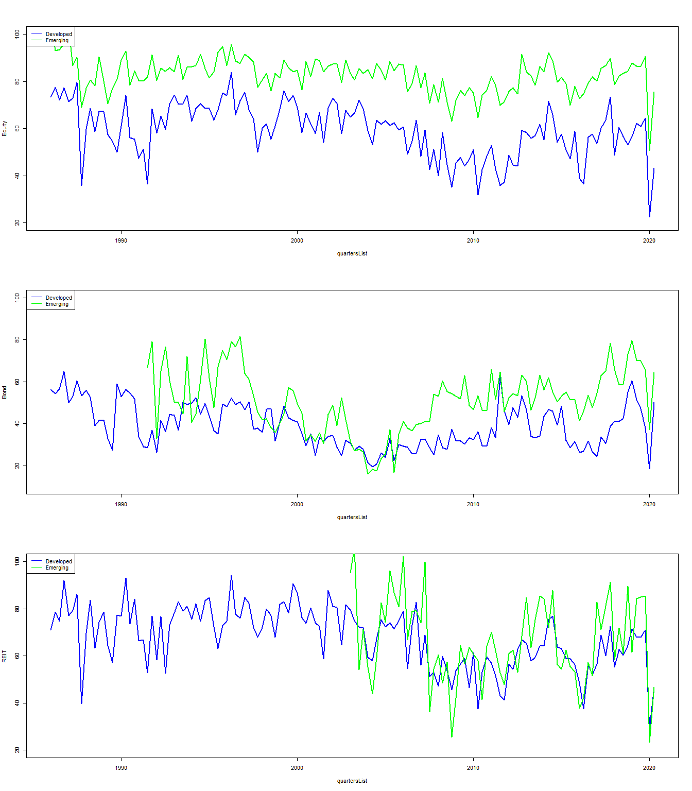

The Developed country list is

## [1] "norway" "australia" "austria"   
## [4] "belgium" "canada" "denmark"   
## [7] "france" "germany" "hong.kong"   
## [10] "ireland" "italy" "japan"   
## [13] "netherlands" "singapore" "south.africa"   
## [16] "switzerland" "uk" "us"   
## [19] "malaysia" "south.korea" "spain"   
## [22] "sweden" "chile" "hungary"   
## [25] "greece" "israel" "luxembourg"   
## [28] "poland" "slovakia" "turkey"   
## [31] "bulgaria" "cyprus" "czech.republic"   
## [34] "estonia" "kazakhstan" "kuwait"   
## [37] "latvia" "lithuania" "slovenia"   
## [40] "malta" "united.arab.emirates" "saudi.arabia"   
## [43] "portugal" "qatar" "bahrain"   
## [46] "croatia" "oman" "argentina"   
## [49] "russia " "montenegro" "romania"

# Table 4

## All time periods

Time Trends for Diversification Indexes Across Three Asset Classes (continued below)

|  |  |  |  |  |
| --- | --- | --- | --- | --- |
| Equity.Developed | Equity.Emerging | Bond.Developed | Bond.Emerging | REIT.Developed |
| -0.1329 | -0.06673 | -0.08963 | 0.03696 | -0.1685 |
| -4.844 | -3.172 | -3.006 | 0.7091 | -6.153 |

|  |
| --- |
| REIT.Emerging |
| -0.108 |
| -0.7939 |

## Pre 2007

Pre 2007 (continued below)

|  |  |  |  |  |
| --- | --- | --- | --- | --- |
| Equity.Developed | Equity.Emerging | Bond.Developed | Bond.Emerging | REIT.Developed |
| -3.323 | -3.389 | -32.61 | -68.35 | -0.1045 |
| -0.7053 | -0.8729 | -8.436 | -6.499 | -0.02212 |

|  |
| --- |
| REIT.Emerging |
| 48.46 |
| 0.4304 |

## 2007-2012

2007-2012 (continued below)

|  |  |  |  |  |
| --- | --- | --- | --- | --- |
| Equity.Developed | Equity.Emerging | Bond.Developed | Bond.Emerging | REIT.Developed |
| -13.43 | 13.68 | 85.51 | 39.58 | -0.8851 |
| -0.608 | 0.6787 | 4.567 | 1.824 | -0.03162 |

|  |
| --- |
| REIT.Emerging |
| -6.274 |
| -0.1212 |

## Post 2012

Post 2012 (continued below)

|  |  |  |  |  |
| --- | --- | --- | --- | --- |
| Equity.Developed | Equity.Emerging | Bond.Developed | Bond.Emerging | REIT.Developed |
| -23.64 | -11.62 | 18.87 | 46.15 | -21.35 |
| -0.9594 | -0.5436 | 0.7634 | 1.944 | -0.7723 |

|  |
| --- |
| REIT.Emerging |
| -23.49 |
| -0.547 |

# Figure 3

## integer(0)

## integer(0)

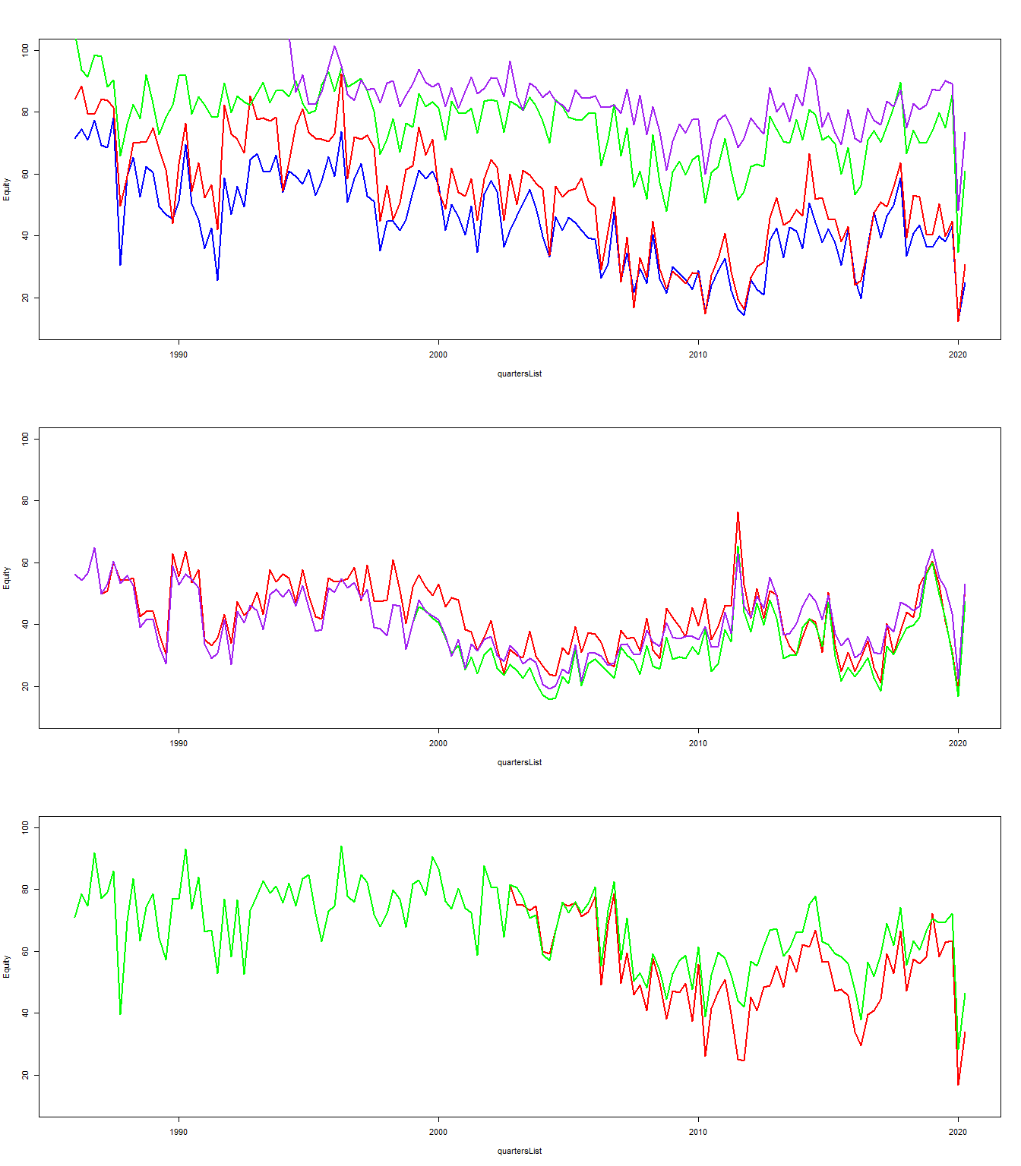

## integer(0)

# Table 7

The FEDFUNDS are from fred and not datastream currently

## Warning in melt(dev_factors, id.vars = c("Country.Name", "Series.Name")):  
## The melt generic in data.table has been passed a data.frame and will attempt  
## to redirect to the relevant reshape2 method; please note that reshape2 is  
## deprecated, and this redirection is now deprecated as well. To continue using  
## melt methods from reshape2 while both libraries are attached, e.g. melt.list,  
## you can prepend the namespace like reshape2::melt(dev_factors). In the next  
## version, this warning will become an error.

## Warning: attributes are not identical across measure variables; they will be  
## dropped

## Warning in dcast(dev_factors, Country.Name + variable ~ Series.Name, sum): The  
## dcast generic in data.table has been passed a data.frame and will attempt to  
## redirect to the reshape2::dcast; please note that reshape2 is deprecated, and  
## this redirection is now deprecated as well. Please do this redirection yourself  
## like reshape2::dcast(dev_factors). In the next version, this warning will become  
## an error.

## Warning: NAs introduced by coercion  
  
## Warning: NAs introduced by coercion

## [1] "All Assets"

## Coefficient p-value  
## (Intercept) 70.534 0.000  
## INTERNET -0.075 0.129  
## ERM -5.492 0.026  
## EUROZONE -5.523 0.025  
## VIX -0.249 0.041  
## TED -4.615 0.087  
## SENT 1.994 0.131  
## FEDFUNDS 0.472 0.332  
## COVID -9.059 0.233  
## 1 0.329 NA

## [1] "All Equity"

## Coefficient p-value  
## (Intercept) 82.518 0.000  
## INTERNET -0.126 0.007  
## ERM -5.186 0.010  
## EUROZONE -6.852 0.032  
## VIX -0.358 0.020  
## TED -5.940 0.072  
## SENT 2.243 0.053  
## FEDFUNDS 0.030 0.949  
## COVID -8.792 0.242  
## 1 0.394 NA

## [1] "Developed Equity"

## Coefficient p-value  
## (Intercept) 64.357 0.000  
## INTERNET -0.123 0.030  
## ERM -6.226 0.017  
## EUROZONE -6.268 0.015  
## VIX -0.266 0.043  
## TED -3.925 0.173  
## SENT 1.873 0.257  
## FEDFUNDS 0.581 0.282  
## COVID -8.313 0.260  
## 1 0.363 NA

## [1] "Emerging Equity"

## Coefficient p-value  
## (Intercept) 85.433 0.000  
## INTERNET -0.045 0.264  
## ERM -3.237 0.160  
## EUROZONE -3.277 0.153  
## VIX -0.254 0.026  
## TED -4.319 0.050  
## SENT 2.080 0.063  
## FEDFUNDS 0.989 0.031  
## COVID -9.444 0.237  
## 1 0.389 NA

## [1] "Frontier Equity"

## Coefficient p-value  
## (Intercept) 93.303 0.000  
## INTERNET -0.092 0.043  
## ERM -3.237 0.144  
## EUROZONE -3.594 0.183  
## VIX -0.169 0.204  
## TED -6.108 0.020  
## SENT 1.749 0.184  
## FEDFUNDS 0.568 0.364  
## COVID -8.349 0.381  
## 1 0.298 NA

## [1] "All Bond"

## Coefficient p-value  
## (Intercept) 35.031 0.000  
## INTERNET 0.071 0.455  
## ERM 0.007 0.999  
## EUROZONE -1.348 0.656  
## VIX -0.066 0.775  
## TED 2.783 0.476  
## SENT 1.411 0.589  
## FEDFUNDS 1.010 0.294  
## COVID -3.109 0.729  
## 1 0.020 NA

## [1] "All REIT"

## Coefficient p-value  
## (Intercept) 77.702 0.000  
## INTERNET -0.194 0.001  
## ERM -12.362 0.000  
## EUROZONE -8.394 0.030  
## VIX -0.083 0.680  
## TED -11.242 0.005  
## SENT 1.759 0.319  
## FEDFUNDS 1.349 0.024  
## COVID -13.686 0.103  
## 1 0.468 NA

## [1] "australia"  
## Coefficient p-value  
## (Intercept) 59.136 0.000  
## INTERNET -0.078 0.360  
## ERM -0.740 0.861  
## EUROZONE -11.491 0.046  
## VIX -0.110 0.666  
## TED -8.811 0.072  
## SENT 2.507 0.382  
## FEDFUNDS 2.763 0.003  
## COVID -10.448 0.301  
## 1 0.322 NA  
## [1] "belgium"  
## Coefficient p-value  
## (Intercept) 27.426 0.000  
## INTERNET -0.021 0.843  
## ERM -7.830 0.017  
## EUROZONE -4.271 0.115  
## VIX -0.110 0.603  
## TED 4.882 0.270  
## SENT 4.655 0.105  
## FEDFUNDS 1.767 0.050  
## COVID -7.523 0.222  
## 1 0.318 NA  
## [1] "canada"  
## Coefficient p-value  
## (Intercept) 85.456 0.000  
## INTERNET -0.350 0.000  
## ERM 5.023 0.161  
## EUROZONE -9.115 0.022  
## VIX -0.716 0.001  
## TED -5.988 0.107  
## SENT 0.876 0.691  
## FEDFUNDS 2.008 0.009  
## COVID -2.818 0.764  
## 1 0.638 NA  
## [1] "france"  
## Coefficient p-value  
## (Intercept) 54.724 0.000  
## INTERNET -0.483 0.000  
## ERM -11.418 0.015  
## EUROZONE -8.520 0.001  
## VIX -0.408 0.028  
## TED -2.792 0.500  
## SENT 1.624 0.412  
## FEDFUNDS 0.910 0.346  
## COVID 11.637 0.066  
## 1 0.644 NA  
## [1] "germany"  
## Coefficient p-value  
## (Intercept) 39.426 0.000  
## INTERNET -0.106 0.221  
## ERM -12.176 0.044  
## EUROZONE -0.480 0.883  
## VIX 0.004 0.984  
## TED 1.050 0.773  
## SENT -0.665 0.729  
## FEDFUNDS 0.514 0.504  
## COVID -14.450 0.021  
## 1 0.132 NA  
## [1] "greece"  
## Coefficient p-value  
## (Intercept) 79.901 0.000  
## INTERNET 0.010 0.952  
## ERM -1.256 0.846  
## EUROZONE 0.635 0.930  
## VIX -0.896 0.099  
## TED -5.321 0.553  
## SENT -2.568 0.580  
## FEDFUNDS 1.485 0.385  
## COVID 2.777 0.729  
## 1 0.047 NA  
## [1] "ireland"  
## Coefficient p-value  
## (Intercept) 46.072 0.000  
## INTERNET 0.016 0.878  
## ERM -9.038 0.148  
## EUROZONE -1.607 0.673  
## VIX -0.382 0.132  
## TED -0.559 0.902  
## SENT 5.627 0.113  
## FEDFUNDS 0.534 0.611  
## COVID -5.882 0.427  
## 1 0.059 NA  
## [1] "italy"  
## Coefficient p-value  
## (Intercept) 61.335 0.000  
## INTERNET -0.186 0.153  
## ERM -2.903 0.747  
## EUROZONE -2.222 0.584  
## VIX -1.104 0.000  
## TED 8.073 0.122  
## SENT 4.786 0.121  
## FEDFUNDS 0.646 0.607  
## COVID 13.167 0.094  
## 1 0.287 NA  
## [1] "japan"  
## Coefficient p-value  
## (Intercept) 85.187 0.000  
## INTERNET -0.340 0.000  
## ERM -7.894 0.065  
## EUROZONE -6.815 0.135  
## VIX 0.144 0.586  
## TED -12.799 0.002  
## SENT 4.705 0.086  
## FEDFUNDS -1.696 0.073  
## COVID 1.274 0.888  
## 1 0.255 NA  
## [1] "mexico"  
## Coefficient p-value  
## (Intercept) 91.561 0.000  
## INTERNET -0.258 0.120  
## ERM 1.794 0.736  
## EUROZONE -18.520 0.005  
## VIX -1.313 0.000  
## TED -4.860 0.528  
## SENT -3.554 0.263  
## FEDFUNDS 1.153 0.487  
## COVID 6.145 0.515  
## 1 0.343 NA  
## [1] "netherlands"  
## Coefficient p-value  
## (Intercept) 25.432 0.000  
## INTERNET -0.056 0.545  
## ERM -5.720 0.122  
## EUROZONE -5.828 0.006  
## VIX -0.016 0.929  
## TED -1.481 0.683  
## SENT 2.267 0.406  
## FEDFUNDS 1.319 0.125  
## COVID -1.593 0.739  
## 1 0.214 NA  
## [1] "new.zealand"  
## Coefficient p-value  
## (Intercept) 69.080 0.000  
## INTERNET 0.008 0.932  
## ERM -5.347 0.284  
## EUROZONE -8.701 0.122  
## VIX -0.551 0.118  
## TED -10.129 0.098  
## SENT -1.589 0.609  
## FEDFUNDS 3.267 0.004  
## COVID -8.840 0.420  
## 1 0.268 NA  
## [1] "portugal"  
## Coefficient p-value  
## (Intercept) 49.912 0.000  
## INTERNET 0.112 0.431  
## EUROZONE -7.794 0.133  
## VIX -1.292 0.000  
## TED 13.389 0.030  
## SENT -1.261 0.742  
## FEDFUNDS -1.504 0.347  
## COVID 13.595 0.052  
## 1 0.242 NA  
## [1] "south.africa"  
## Coefficient p-value  
## (Intercept) 95.610 0.000  
## INTERNET -0.786 0.000  
## ERM -21.969 0.000  
## EUROZONE -2.862 0.519  
## VIX -0.186 0.450  
## TED -12.664 0.001  
## SENT 1.632 0.436  
## FEDFUNDS -0.017 0.988  
## COVID 10.769 0.332  
## 1 0.678 NA  
## [1] "spain"  
## Coefficient p-value  
## (Intercept) 48.438 0.000  
## INTERNET -0.133 0.356  
## ERM 7.294 0.248  
## EUROZONE 0.940 0.791  
## VIX -1.139 0.000  
## TED 11.838 0.052  
## SENT 4.913 0.298  
## FEDFUNDS 0.999 0.501  
## COVID 10.168 0.142  
## 1 0.235 NA  
## [1] "uk"  
## Coefficient p-value  
## (Intercept) 51.176 0.000  
## INTERNET -0.088 0.255  
## ERM -9.305 0.019  
## EUROZONE -1.055 0.818  
## VIX 0.232 0.292  
## TED -6.451 0.115  
## SENT 3.545 0.174  
## FEDFUNDS 1.816 0.027  
## COVID -22.024 0.013  
## 1 0.251 NA  
## [1] "us"  
## Coefficient p-value  
## (Intercept) 67.018 0.000  
## INTERNET -0.110 0.043  
## ERM -2.637 0.193  
## EUROZONE -9.434 0.017  
## VIX -0.265 0.112  
## TED -6.483 0.060  
## SENT 0.302 0.857  
## FEDFUNDS 1.675 0.002  
## COVID -10.440 0.150  
## 1 0.446 NA

# Table 8

## Global Internet

Equity

|  |  |  |
| --- | --- | --- |
|  | Estimate | P-Value |
| **TED** | -3.029 | 0 |
| **VIX** | -0.548 | 0 |
| **SENT** | 0.147 | 0.683 |
| **FEDFUNDS** | 0.732 | 0 |
| **INTERNET** | -0.248 | 0 |
| **ERM** | 0.516 | 0.71 |
| **EUROZONE** | -6.239 | 0 |
| **COVID** | -4.503 | 0.002 |
| **Adj. R sq** | 0.188 | NA |
| **N Obs.** | 9765 | NA |

Bond

|  |  |  |
| --- | --- | --- |
|  | Estimate | P-Value |
| **TED** | -1.263 | 0.303 |
| **VIX** | 0.034 | 0.618 |
| **SENT** | 0.081 | 0.898 |
| **FEDFUNDS** | 1.303 | 0 |
| **INTERNET** | 0.011 | 0.605 |
| **ERM** | 2.399 | 0.282 |
| **EUROZONE** | -3.607 | 0.014 |
| **COVID** | -3.373 | 0.2 |
| **Adj. R sq** | 0.021 | NA |
| **N Obs.** | 3137 | NA |

REIT

|  |  |  |
| --- | --- | --- |
|  | Estimate | P-Value |
| **TED** | -10.95 | 0 |
| **VIX** | -0.163 | 0.12 |
| **SENT** | 1.391 | 0.184 |
| **FEDFUNDS** | 1.966 | 0 |
| **INTERNET** | -0.303 | 0 |
| **ERM** | -12.14 | 0.002 |
| **EUROZONE** | -6.795 | 0.001 |
| **COVID** | -11.26 | 0.001 |
| **Adj. R sq** | 0.235 | NA |
| **N Obs.** | 1776 | NA |

## Local Internet

Equity

|  |  |  |
| --- | --- | --- |
|  | Estimate | P-Value |
| **TED** | -2.698 | 0 |
| **VIX** | -0.491 | 0 |
| **SENT** | 0.684 | 0.055 |
| **FEDFUNDS** | 1.024 | 0 |
| **INTERNET** | -0.204 | 0 |
| **ERM** | 0.405 | 0.769 |
| **EUROZONE** | -5.541 | 0 |
| **COVID** | -11.42 | 0 |
| **Adj. R sq** | 0.195 | NA |
| **N Obs.** | 9668 | NA |

Bond

|  |  |  |
| --- | --- | --- |
|  | Estimate | P-Value |
| **TED** | 0.312 | 0.804 |
| **VIX** | -0.05 | 0.465 |
| **SENT** | -0.259 | 0.685 |
| **FEDFUNDS** | 0.423 | 0.085 |
| **INTERNET** | -0.081 | 0 |
| **ERM** | -1.513 | 0.506 |
| **EUROZONE** | -3.319 | 0.026 |
| **COVID** | -3.314 | 0.198 |
| **Adj. R sq** | 0.028 | NA |
| **N Obs.** | 3057 | NA |

REIT

|  |  |  |
| --- | --- | --- |
|  | Estimate | P-Value |
| **TED** | -10.16 | 0 |
| **VIX** | -0.082 | 0.423 |
| **SENT** | 2.301 | 0.026 |
| **FEDFUNDS** | 1.879 | 0 |
| **INTERNET** | -0.248 | 0 |
| **ERM** | -14.31 | 0 |
| **EUROZONE** | -5.473 | 0.01 |
| **COVID** | -20.63 | 0 |
| **Adj. R sq** | 0.234 | NA |
| **N Obs.** | 1776 | NA |

## DEVPC1

Internet is the DEVPC1 factor The column is dropped for the country if we have more than 50% missing values The missing values are filled by using interpolation

Equity

|  |  |  |
| --- | --- | --- |
|  | Estimate | P-Value |
| **TED** | -3.77 | 0 |
| **VIX** | -0.437 | 0 |
| **SENT** | 0.884 | 0.013 |
| **FEDFUNDS** | 1.292 | 0 |
| **INTERNET** | -0.076 | 0 |
| **ERM** | 2.65 | 0.051 |
| **EUROZONE** | -5.123 | 0 |
| **COVID** | -10.48 | 0 |
| **Adj. R sq** | 0.196 | NA |
| **N Obs.** | 9668 | NA |

Bond

|  |  |  |
| --- | --- | --- |
|  | Estimate | P-Value |
| **TED** | 0.318 | 0.796 |
| **VIX** | -0.061 | 0.358 |
| **SENT** | -0.417 | 0.51 |
| **FEDFUNDS** | 0.145 | 0.524 |
| **INTERNET** | -0.063 | 0 |
| **ERM** | -2.202 | 0.32 |
| **EUROZONE** | -3.42 | 0.021 |
| **COVID** | -1.714 | 0.504 |
| **Adj. R sq** | 0.039 | NA |
| **N Obs.** | 3057 | NA |

REIT

|  |  |  |
| --- | --- | --- |
|  | Estimate | P-Value |
| **TED** | -11.69 | 0 |
| **VIX** | 0.009 | 0.931 |
| **SENT** | 2.799 | 0.007 |
| **FEDFUNDS** | 2.952 | 0 |
| **INTERNET** | -0.082 | 0 |
| **ERM** | -8.425 | 0.029 |
| **EUROZONE** | -5.137 | 0.017 |
| **COVID** | -18.63 | 0 |
| **Adj. R sq** | 0.219 | NA |
| **N Obs.** | 1776 | NA |

# Table 9

## No INTERNET

Equity

|  |  |  |
| --- | --- | --- |
|  | Estimate | P-Value |
| **TED** | -4.422 | 0 |
| **VIX** | -0.318 | 0 |
| **SENT** | 1.303 | 0 |
| **FEDFUNDS** | 2.012 | 0 |
| **ERM** | 3.882 | 0.004 |
| **EUROZONE** | -5.19 | 0 |
| **COVID** | -14.68 | 0 |
| **Aggregate.Economic.Risk** | -0.319 | 0 |
| **Aggregate.Financial.Risk** | 0.274 | 0 |
| **Aggregate.Poliitical.Risk** | -0.183 | 0 |
| **liquidity** | 1.624 | 0.196 |
| **insti_loan** | -0.372 | 0 |
| **Adj. R sq** | 0.191 | NA |
| **N Obs.** | 9668 | NA |

Bond

|  |  |  |
| --- | --- | --- |
|  | Estimate | P-Value |
| **TED** | -2.009 | 0.105 |
| **VIX** | 0.231 | 0.001 |
| **SENT** | 0.598 | 0.344 |
| **FEDFUNDS** | 0.794 | 0 |
| **ERM** | -2.946 | 0.17 |
| **EUROZONE** | -6.595 | 0 |
| **COVID** | -7.486 | 0.003 |
| **Aggregate.Economic.Risk** | -0.883 | 0 |
| **Aggregate.Financial.Risk** | 0.795 | 0 |
| **Aggregate.Poliitical.Risk** | -0.295 | 0.001 |
| **liquidity** | 1.899 | 0.436 |
| **insti_loan** | 0.069 | 0.119 |
| **Adj. R sq** | 0.079 | NA |
| **N Obs.** | 3057 | NA |

REIT

|  |  |  |
| --- | --- | --- |
|  | Estimate | P-Value |
| **TED** | -11.23 | 0 |
| **VIX** | -0.04 | 0.702 |
| **SENT** | 1.75 | 0.103 |
| **FEDFUNDS** | 3.353 | 0 |
| **ERM** | -5.508 | 0.155 |
| **EUROZONE** | -3.148 | 0.155 |
| **COVID** | -17.4 | 0 |
| **Aggregate.Economic.Risk** | 0.354 | 0.038 |
| **Aggregate.Financial.Risk** | 0.278 | 0.321 |
| **Aggregate.Poliitical.Risk** | -0.14 | 0.408 |
| **liquidity** | 1.236 | 0.782 |
| **insti_loan** | -0.383 | 0 |
| **Adj. R sq** | 0.219 | NA |
| **N Obs.** | 1776 | NA |

## Internet

Equity

|  |  |  |
| --- | --- | --- |
|  | Estimate | P-Value |
| **TED** | -2.599 | 0 |
| **VIX** | -0.528 | 0 |
| **SENT** | 0.4 | 0.264 |
| **FEDFUNDS** | 0.615 | 0 |
| **INTERNET** | -0.221 | 0 |
| **ERM** | -0.793 | 0.564 |
| **EUROZONE** | -5.585 | 0 |
| **COVID** | -6.943 | 0 |
| **Aggregate.Economic.Risk** | -0.105 | 0.046 |
| **Aggregate.Financial.Risk** | 0.282 | 0 |
| **Aggregate.Poliitical.Risk** | -0.308 | 0 |
| **liquidity** | 1.551 | 0.211 |
| **insti_loan** | -0.269 | 0 |
| **Adj. R sq** | 0.213 | NA |
| **N Obs.** | 9668 | NA |

Bond

|  |  |  |
| --- | --- | --- |
|  | Estimate | P-Value |
| **TED** | -2.784 | 0.025 |
| **VIX** | 0.355 | 0 |
| **SENT** | 1.175 | 0.065 |
| **FEDFUNDS** | 1.631 | 0 |
| **INTERNET** | 0.157 | 0 |
| **ERM** | -0.513 | 0.813 |
| **EUROZONE** | -6.383 | 0 |
| **COVID** | -12.71 | 0 |
| **Aggregate.Economic.Risk** | -1.129 | 0 |
| **Aggregate.Financial.Risk** | 0.91 | 0 |
| **Aggregate.Poliitical.Risk** | -0.214 | 0.02 |
| **liquidity** | 0.471 | 0.847 |
| **insti_loan** | -0.025 | 0.596 |
| **Adj. R sq** | 0.089 | NA |
| **N Obs.** | 3057 | NA |

REIT

|  |  |  |
| --- | --- | --- |
|  | Estimate | P-Value |
| **TED** | -9.737 | 0 |
| **VIX** | -0.288 | 0.008 |
| **SENT** | 0.366 | 0.732 |
| **FEDFUNDS** | 1.81 | 0 |
| **INTERNET** | -0.303 | 0 |
| **ERM** | -10.61 | 0.006 |
| **EUROZONE** | -4.201 | 0.054 |
| **COVID** | -8.013 | 0.023 |
| **Aggregate.Economic.Risk** | 0.751 | 0 |
| **Aggregate.Financial.Risk** | -0.115 | 0.681 |
| **Aggregate.Poliitical.Risk** | -0.206 | 0.215 |
| **liquidity** | 3.658 | 0.407 |
| **insti_loan** | -0.223 | 0 |
| **Adj. R sq** | 0.246 | NA |
| **N Obs.** | 1776 | NA |

## PC1

Equity

|  |  |  |
| --- | --- | --- |
|  | Estimate | P-Value |
| **TED** | -2.954 | 0 |
| **VIX** | -0.439 | 0 |
| **SENT** | 0.94 | 0.008 |
| **FEDFUNDS** | 0.997 | 0 |
| **PC** | -0.066 | 0 |
| **ERM** | 0.541 | 0.689 |
| **EUROZONE** | -4.995 | 0 |
| **COVID** | -12.05 | 0 |
| **Aggregate.Economic.Risk** | -0.212 | 0 |
| **Aggregate.Financial.Risk** | 0.218 | 0.001 |
| **Aggregate.Poliitical.Risk** | -0.2 | 0 |
| **liquidity** | 3.281 | 0.008 |
| **insti_loan** | -0.293 | 0 |
| **Adj. R sq** | 0.217 | NA |
| **N Obs.** | 9668 | NA |

Bond

|  |  |  |
| --- | --- | --- |
|  | Estimate | P-Value |
| **TED** | -1.378 | 0.268 |
| **VIX** | 0.185 | 0.009 |
| **SENT** | 0.413 | 0.513 |
| **FEDFUNDS** | 0.266 | 0.247 |
| **PC** | -0.04 | 0 |
| **ERM** | -4.835 | 0.027 |
| **EUROZONE** | -6.248 | 0 |
| **COVID** | -6.288 | 0.014 |
| **Aggregate.Economic.Risk** | -0.742 | 0 |
| **Aggregate.Financial.Risk** | 0.818 | 0 |
| **Aggregate.Poliitical.Risk** | -0.36 | 0 |
| **liquidity** | 2.554 | 0.294 |
| **insti_loan** | 0.103 | 0.021 |
| **Adj. R sq** | 0.085 | NA |
| **N Obs.** | 3057 | NA |

REIT

|  |  |  |
| --- | --- | --- |
|  | Estimate | P-Value |
| **TED** | -10.19 | 0 |
| **VIX** | -0.103 | 0.327 |
| **SENT** | 1.607 | 0.131 |
| **FEDFUNDS** | 2.563 | 0 |
| **PC** | -0.07 | 0 |
| **ERM** | -9.144 | 0.019 |
| **EUROZONE** | -3.354 | 0.126 |
| **COVID** | -15.94 | 0 |
| **Aggregate.Economic.Risk** | 0.346 | 0.041 |
| **Aggregate.Financial.Risk** | 0.435 | 0.119 |
| **Aggregate.Poliitical.Risk** | -0.219 | 0.192 |
| **liquidity** | 2.109 | 0.635 |
| **insti_loan** | -0.315 | 0 |
| **Adj. R sq** | 0.234 | NA |
| **N Obs.** | 1776 | NA |

# Table 10

## Geographical Cohorts

Developed Equity

|  |  |  |
| --- | --- | --- |
|  | Estimate | P-Value |
| **TED** | -2.76 | 0.002 |
| **VIX** | -0.621 | 0 |
| **SENT** | 0.297 | 0.516 |
| **FEDFUNDS** | 0.53 | 0.003 |
| **INTERNET** | -0.314 | 0 |
| **ERM** | -0.66 | 0.704 |
| **EUROZONE** | -7.224 | 0 |
| **COVID** | -4.997 | 0.013 |
| **Aggregate.Economic.Risk** | -0.005 | 0.942 |
| **Aggregate.Financial.Risk** | 0.195 | 0.031 |
| **Aggregate.Poliitical.Risk** | -0.319 | 0 |
| **liquidity** | 2.603 | 0.114 |
| **insti_loan** | -0.155 | 0 |
| **Adj. R sq** | 0.279 | NA |
| **N Obs.** | 5853 | NA |

Emerging Equity

|  |  |  |
| --- | --- | --- |
|  | Estimate | P-Value |
| **TED** | -2.194 | 0.039 |
| **VIX** | -0.423 | 0 |
| **SENT** | 0.571 | 0.316 |
| **FEDFUNDS** | 0.553 | 0.01 |
| **INTERNET** | -0.08 | 0 |
| **ERM** | -0.708 | 0.754 |
| **EUROZONE** | -3.16 | 0.009 |
| **COVID** | -10.28 | 0 |
| **Aggregate.Economic.Risk** | -0.036 | 0.675 |
| **Aggregate.Financial.Risk** | -0.156 | 0.111 |
| **Aggregate.Poliitical.Risk** | -0.149 | 0.009 |
| **liquidity** | 3.223 | 0.089 |
| **insti_loan** | -0.371 | 0 |
| **Adj. R sq** | 0.109 | NA |
| **N Obs.** | 3912 | NA |

Frontier Equity

|  |  |  |
| --- | --- | --- |
|  | Estimate | P-Value |
| **TED** | -5.769 | 0 |
| **VIX** | -0.16 | 0.024 |
| **SENT** | 0.685 | 0.297 |
| **FEDFUNDS** | 0.738 | 0.006 |
| **INTERNET** | -0.017 | 0.49 |
| **ERM** | -4.559 | 0.203 |
| **EUROZONE** | -3.223 | 0.017 |
| **COVID** | -11.67 | 0 |
| **Aggregate.Economic.Risk** | -0.277 | 0.006 |
| **Aggregate.Financial.Risk** | 0.16 | 0.169 |
| **Aggregate.Poliitical.Risk** | -0.174 | 0.002 |
| **liquidity** | -0.535 | 0.82 |
| **insti_loan** | -0.594 | 0 |
| **Adj. R sq** | 0.082 | NA |
| **N Obs.** | 2689 | NA |

## Time based cohorts

### Pre 2007

Equity

|  |  |  |
| --- | --- | --- |
|  | Estimate | P-Value |
| **TED** | -0.092 | 0.948 |
| **VIX** | -0.422 | 0 |
| **SENT** | 0.487 | 0.192 |
| **FEDFUNDS** | -0.898 | 0 |
| **INTERNET** | -0.587 | 0 |
| **ERM** | -4.63 | 0.001 |
| **Aggregate.Economic.Risk** | 0.172 | 0.036 |
| **Aggregate.Financial.Risk** | 0.252 | 0.012 |
| **Aggregate.Poliitical.Risk** | -0.328 | 0 |
| **liquidity** | -1.413 | 0.464 |
| **insti_loan** | -0.189 | 0 |
| **Adj. R sq** | 0.077 | NA |
| **N Obs.** | 4868 | NA |

Bond

|  |  |  |
| --- | --- | --- |
|  | Estimate | P-Value |
| **TED** | 1.835 | 0.392 |
| **VIX** | -0.017 | 0.847 |
| **SENT** | 0.809 | 0.156 |
| **FEDFUNDS** | 0.52 | 0.125 |
| **INTERNET** | -0.481 | 0 |
| **ERM** | -5.935 | 0.002 |
| **Aggregate.Economic.Risk** | -0.685 | 0 |
| **Aggregate.Financial.Risk** | 0.652 | 0.002 |
| **Aggregate.Poliitical.Risk** | -0.036 | 0.762 |
| **liquidity** | -12.67 | 0 |
| **insti_loan** | -0.261 | 0 |
| **Adj. R sq** | 0.266 | NA |
| **N Obs.** | 1614 | NA |

REIT

|  |  |  |
| --- | --- | --- |
|  | Estimate | P-Value |
| **TED** | -4.455 | 0.27 |
| **VIX** | 0.051 | 0.731 |
| **SENT** | 0.946 | 0.396 |
| **FEDFUNDS** | 0.293 | 0.647 |
| **INTERNET** | -0.028 | 0.813 |
| **ERM** | -12.19 | 0.002 |
| **Aggregate.Economic.Risk** | 0.155 | 0.579 |
| **Aggregate.Financial.Risk** | 0.587 | 0.24 |
| **Aggregate.Poliitical.Risk** | -0.453 | 0.112 |
| **liquidity** | -13.41 | 0.193 |
| **insti_loan** | -0.417 | 0 |
| **Adj. R sq** | 0.023 | NA |
| **N Obs.** | 719 | NA |

### 2007-2012

Equity

|  |  |  |
| --- | --- | --- |
|  | Estimate | P-Value |
| **TED** | 4.168 | 0 |
| **VIX** | -0.909 | 0 |
| **SENT** | -4.158 | 0.039 |
| **FEDFUNDS** | -1.979 | 0.012 |
| **INTERNET** | -0.848 | 0 |
| **Aggregate.Economic.Risk** | 0.009 | 0.965 |
| **Aggregate.Financial.Risk** | 0.783 | 0.002 |
| **Aggregate.Poliitical.Risk** | -1.001 | 0 |
| **liquidity** | -2.468 | 0.637 |
| **insti_loan** | 0.007 | 0.966 |
| **Adj. R sq** | 0.039 | NA |
| **N Obs.** | 2164 | NA |

Bond

|  |  |  |
| --- | --- | --- |
|  | Estimate | P-Value |
| **TED** | -7.522 | 0 |
| **VIX** | 1.244 | 0 |
| **SENT** | 3.323 | 0.338 |
| **FEDFUNDS** | 6.208 | 0 |
| **INTERNET** | 1.458 | 0 |
| **Aggregate.Economic.Risk** | -1.028 | 0.01 |
| **Aggregate.Financial.Risk** | 1.589 | 0.013 |
| **Aggregate.Poliitical.Risk** | -2.977 | 0 |
| **liquidity** | 36.79 | 0.001 |
| **insti_loan** | -0.56 | 0.161 |
| **Adj. R sq** | 0.28 | NA |
| **N Obs.** | 653 | NA |

REIT

|  |  |  |
| --- | --- | --- |
|  | Estimate | P-Value |
| **TED** | 4.915 | 0.07 |
| **VIX** | -1.125 | 0 |
| **SENT** | -6.566 | 0.173 |
| **FEDFUNDS** | -3.045 | 0.1 |
| **INTERNET** | -1.194 | 0.003 |
| **Aggregate.Economic.Risk** | 0.215 | 0.736 |
| **Aggregate.Financial.Risk** | 1.37 | 0.224 |
| **Aggregate.Poliitical.Risk** | -0.455 | 0.444 |
| **liquidity** | -1.11 | 0.918 |
| **insti_loan** | -1.551 | 0.024 |
| **Adj. R sq** | 0.045 | NA |
| **N Obs.** | 407 | NA |

### Post 2012

Equity

|  |  |  |
| --- | --- | --- |
|  | Estimate | P-Value |
| **TED** | 4.242 | 0.164 |
| **VIX** | -2.045 | 0 |
| **SENT** | 9.369 | 0 |
| **FEDFUNDS** | 1.183 | 0.417 |
| **INTERNET** | 0.224 | 0.179 |
| **Aggregate.Economic.Risk** | 0.44 | 0.006 |
| **Aggregate.Financial.Risk** | -0.282 | 0.098 |
| **Aggregate.Poliitical.Risk** | -0.297 | 0.002 |
| **liquidity** | -1.829 | 0.545 |
| **COVID** | 11.28 | 0 |
| **insti_loan** | -0.307 | 0.009 |
| **Adj. R sq** | 0.18 | NA |
| **N Obs.** | 2733 | NA |

Bond

|  |  |  |
| --- | --- | --- |
|  | Estimate | P-Value |
| **TED** | 20.31 | 0 |
| **VIX** | 0.213 | 0.372 |
| **SENT** | 25.29 | 0 |
| **FEDFUNDS** | 12.01 | 0 |
| **INTERNET** | -0.447 | 0.143 |
| **Aggregate.Economic.Risk** | -1.236 | 0.003 |
| **Aggregate.Financial.Risk** | 0.44 | 0.27 |
| **Aggregate.Poliitical.Risk** | 0.023 | 0.928 |
| **liquidity** | -5.577 | 0.353 |
| **COVID** | -10.82 | 0.056 |
| **insti_loan** | -0.267 | 0.22 |
| **Adj. R sq** | 0.109 | NA |
| **N Obs.** | 870 | NA |

REIT

|  |  |  |
| --- | --- | --- |
|  | Estimate | P-Value |
| **TED** | -8.24 | 0.28 |
| **VIX** | -1.77 | 0 |
| **SENT** | 19.09 | 0.003 |
| **FEDFUNDS** | 2.565 | 0.494 |
| **INTERNET** | 0.286 | 0.51 |
| **Aggregate.Economic.Risk** | -0.218 | 0.702 |
| **Aggregate.Financial.Risk** | -0.61 | 0.35 |
| **Aggregate.Poliitical.Risk** | -0.057 | 0.883 |
| **liquidity** | -6.11 | 0.471 |
| **COVID** | 9.522 | 0.222 |
| **insti_loan** | -0.292 | 0.307 |
| **Adj. R sq** | 0.146 | NA |
| **N Obs.** | 650 | NA |

# Appendix Table 5

## Geographical Cohorts

Developed Equity

|  |  |  |
| --- | --- | --- |
|  | Estimate | P-Value |
| **TED** | -2.64 | 0.002 |
| **VIX** | -0.525 | 0 |
| **SENT** | 0.925 | 0.04 |
| **FEDFUNDS** | 0.57 | 0.001 |
| **PC** | -0.114 | 0 |
| **ERM** | -1.233 | 0.476 |
| **EUROZONE** | -6.181 | 0 |
| **COVID** | -11.66 | 0 |
| **Aggregate.Economic.Risk** | -0.175 | 0.008 |
| **Aggregate.Financial.Risk** | 0.397 | 0 |
| **Aggregate.Poliitical.Risk** | -0.294 | 0 |
| **liquidity** | -0.011 | 0.995 |
| **insti_loan** | -0.19 | 0 |
| **Adj. R sq** | 0.285 | NA |
| **N Obs.** | 5853 | NA |

Emerging Equity

|  |  |  |
| --- | --- | --- |
|  | Estimate | P-Value |
| **TED** | -2.187 | 0.038 |
| **VIX** | -0.403 | 0 |
| **SENT** | 0.793 | 0.159 |
| **FEDFUNDS** | 0.62 | 0.001 |
| **PC** | -0.035 | 0 |
| **ERM** | -0.185 | 0.933 |
| **EUROZONE** | -2.712 | 0.025 |
| **COVID** | -11.83 | 0 |
| **Aggregate.Economic.Risk** | -0.052 | 0.535 |
| **Aggregate.Financial.Risk** | -0.17 | 0.082 |
| **Aggregate.Poliitical.Risk** | -0.063 | 0.243 |
| **liquidity** | 6.528 | 0.001 |
| **insti_loan** | -0.354 | 0 |
| **Adj. R sq** | 0.121 | NA |
| **N Obs.** | 3815 | NA |

Frontier Equity

|  |  |  |
| --- | --- | --- |
|  | Estimate | P-Value |
| **TED** | -5.577 | 0 |
| **VIX** | -0.168 | 0.011 |
| **SENT** | 0.691 | 0.29 |
| **FEDFUNDS** | 0.679 | 0.003 |
| **PC** | -0.012 | 0.023 |
| **ERM** | -4.513 | 0.201 |
| **EUROZONE** | -3.1 | 0.021 |
| **COVID** | -11.86 | 0 |
| **Aggregate.Economic.Risk** | -0.276 | 0.006 |
| **Aggregate.Financial.Risk** | 0.119 | 0.304 |
| **Aggregate.Poliitical.Risk** | -0.151 | 0.005 |
| **liquidity** | 0.313 | 0.896 |
| **insti_loan** | -0.568 | 0 |
| **Adj. R sq** | 0.083 | NA |
| **N Obs.** | 2689 | NA |

## Time based cohorts

### Pre 20077

Equity

|  |  |  |
| --- | --- | --- |
|  | Estimate | P-Value |
| **TED** | 0.319 | 0.821 |
| **VIX** | -0.301 | 0 |
| **SENT** | 1.001 | 0.007 |
| **FEDFUNDS** | -0.485 | 0.028 |
| **PC** | -0.132 | 0 |
| **ERM** | -2.705 | 0.051 |
| **Aggregate.Economic.Risk** | -0.136 | 0.062 |
| **Aggregate.Financial.Risk** | 0.169 | 0.094 |
| **Aggregate.Poliitical.Risk** | -0.16 | 0.001 |
| **liquidity** | 0.855 | 0.656 |
| **insti_loan** | -0.133 | 0.003 |
| **Adj. R sq** | 0.074 | NA |
| **N Obs.** | 4825 | NA |

Bond

|  |  |  |
| --- | --- | --- |
|  | Estimate | P-Value |
| **TED** | 2.812 | 0.186 |
| **VIX** | 0.06 | 0.477 |
| **SENT** | 1.149 | 0.046 |
| **FEDFUNDS** | 0.63 | 0.059 |
| **PC** | -0.106 | 0 |
| **ERM** | -5.43 | 0.005 |
| **Aggregate.Economic.Risk** | -0.829 | 0 |
| **Aggregate.Financial.Risk** | 0.824 | 0 |
| **Aggregate.Poliitical.Risk** | -0.048 | 0.688 |
| **liquidity** | -13.97 | 0 |
| **insti_loan** | -0.33 | 0 |
| **Adj. R sq** | 0.275 | NA |
| **N Obs.** | 1588 | NA |

REIT

|  |  |  |
| --- | --- | --- |
|  | Estimate | P-Value |
| **TED** | -4.156 | 0.301 |
| **VIX** | 0.056 | 0.702 |
| **SENT** | 0.846 | 0.447 |
| **FEDFUNDS** | 0.543 | 0.383 |
| **PC** | 0.041 | 0.058 |
| **ERM** | -10.66 | 0.005 |
| **Aggregate.Economic.Risk** | 0.049 | 0.838 |
| **Aggregate.Financial.Risk** | 0.47 | 0.348 |
| **Aggregate.Poliitical.Risk** | -0.365 | 0.198 |
| **liquidity** | -12.92 | 0.205 |
| **insti_loan** | -0.476 | 0 |
| **Adj. R sq** | 0.028 | NA |
| **N Obs.** | 719 | NA |

### 2007 - 2012

Equity

|  |  |  |
| --- | --- | --- |
|  | Estimate | P-Value |
| **TED** | 2.454 | 0.027 |
| **VIX** | -0.546 | 0 |
| **SENT** | -8.717 | 0 |
| **FEDFUNDS** | 1.59 | 0 |
| **PC** | 0.024 | 0.211 |
| **Aggregate.Economic.Risk** | -0.093 | 0.631 |
| **Aggregate.Financial.Risk** | 0.73 | 0.004 |
| **Aggregate.Poliitical.Risk** | -0.574 | 0.006 |
| **liquidity** | -2.053 | 0.696 |
| **insti_loan** | 0.036 | 0.833 |
| **Adj. R sq** | 0.028 | NA |
| **N Obs.** | 2140 | NA |

Bond

|  |  |  |
| --- | --- | --- |
|  | Estimate | P-Value |
| **TED** | -5.171 | 0.01 |
| **VIX** | 0.631 | 0 |
| **SENT** | 11.19 | 0.001 |
| **FEDFUNDS** | -0.282 | 0.733 |
| **PC** | -0.082 | 0.265 |
| **Aggregate.Economic.Risk** | -0.597 | 0.149 |
| **Aggregate.Financial.Risk** | 1.413 | 0.031 |
| **Aggregate.Poliitical.Risk** | -3.544 | 0 |
| **liquidity** | 36.8 | 0.001 |
| **insti_loan** | -0.67 | 0.105 |
| **Adj. R sq** | 0.253 | NA |
| **N Obs.** | 629 | NA |

REIT

|  |  |  |
| --- | --- | --- |
|  | Estimate | P-Value |
| **TED** | 2.233 | 0.404 |
| **VIX** | -0.57 | 0.005 |
| **SENT** | -13.1 | 0.003 |
| **FEDFUNDS** | 2.396 | 0.03 |
| **PC** | 0.096 | 0.315 |
| **Aggregate.Economic.Risk** | 0.02 | 0.976 |
| **Aggregate.Financial.Risk** | 1.216 | 0.294 |
| **Aggregate.Poliitical.Risk** | -0.08 | 0.895 |
| **liquidity** | -0.275 | 0.98 |
| **insti_loan** | -1.238 | 0.091 |
| **Adj. R sq** | 0.024 | NA |
| **N Obs.** | 407 | NA |

### Post 2012

Equity

|  |  |  |
| --- | --- | --- |
|  | Estimate | P-Value |
| **TED** | 8.01 | 0 |
| **VIX** | -2.017 | 0 |
| **SENT** | 9.662 | 0 |
| **FEDFUNDS** | 3.297 | 0 |
| **PC** | -0.07 | 0.024 |
| **Aggregate.Economic.Risk** | 0.43 | 0.007 |
| **Aggregate.Financial.Risk** | -0.26 | 0.122 |
| **Aggregate.Poliitical.Risk** | -0.274 | 0.003 |
| **liquidity** | -1.453 | 0.631 |
| **insti_loan** | -0.297 | 0.012 |
| **COVID** | 12.03 | 0 |
| **Adj. R sq** | 0.183 | NA |
| **N Obs.** | 2703 | NA |

Bond

|  |  |  |
| --- | --- | --- |
|  | Estimate | P-Value |
| **TED** | 16.09 | 0 |
| **VIX** | 0.268 | 0.264 |
| **SENT** | 24.64 | 0 |
| **FEDFUNDS** | 8.647 | 0 |
| **PC** | -0.215 | 0.009 |
| **Aggregate.Economic.Risk** | -1.389 | 0.001 |
| **Aggregate.Financial.Risk** | 0.627 | 0.09 |
| **Aggregate.Poliitical.Risk** | 0.01 | 0.966 |
| **liquidity** | -3.806 | 0.523 |
| **insti_loan** | -0.296 | 0.173 |
| **COVID** | -15.44 | 0.005 |
| **Adj. R sq** | 0.109 | NA |
| **N Obs.** | 840 | NA |

REIT

|  |  |  |
| --- | --- | --- |
|  | Estimate | P-Value |
| **TED** | -1.152 | 0.832 |
| **VIX** | -1.726 | 0 |
| **SENT** | 18.7 | 0.003 |
| **FEDFUNDS** | 6.463 | 0 |
| **PC** | -0.338 | 0.008 |
| **Aggregate.Economic.Risk** | -0.23 | 0.684 |
| **Aggregate.Financial.Risk** | -0.587 | 0.353 |
| **Aggregate.Poliitical.Risk** | -0.092 | 0.812 |
| **liquidity** | -4.677 | 0.578 |
| **insti_loan** | -0.426 | 0.14 |
| **COVID** | 10.87 | 0.146 |
| **Adj. R sq** | 0.155 | NA |
| **N Obs.** | 650 | NA |

# Table 6

## Excluding countries from picture

## INTERNET ERM EUROZONE VIX TED  
## INTERNET 1.0000000 -0.176906103 0.16055109 -0.11076337 -0.37005871  
## ERM -0.1769061 1.000000000 -0.04285988 -0.11548088 -0.07234008  
## EUROZONE 0.1605511 -0.042859876 1.00000000 0.28799134 -0.12044555  
## VIX -0.1107634 -0.115480881 0.28799134 1.00000000 0.47040635  
## TED -0.3700587 -0.072340081 -0.12044555 0.47040635 1.00000000  
## SENT -0.4577021 0.126233192 -0.27469265 0.00150141 0.10250164  
## FEDFUNDS -0.7744714 0.007000966 -0.29720084 0.04974831 0.56658851  
## COVID 0.2330130 -0.020951887 -0.03008284 0.25762487 0.07498884  
## Var1 0.9680149 -0.186495772 0.16813573 -0.10213072 -0.44228284  
## SENT FEDFUNDS COVID Var1  
## INTERNET -0.45770215 -0.774471363 0.23301298 0.9680149  
## ERM 0.12623319 0.007000966 -0.02095189 -0.1864958  
## EUROZONE -0.27469265 -0.297200835 -0.03008284 0.1681357  
## VIX 0.00150141 0.049748310 0.25762487 -0.1021307  
## TED 0.10250164 0.566588512 0.07498884 -0.4422828  
## SENT 1.00000000 0.386662398 -0.09253328 -0.4131095  
## FEDFUNDS 0.38666240 1.000000000 -0.12323137 -0.8172463  
## COVID -0.09253328 -0.123231372 1.00000000 0.2070034  
## Var1 -0.41310947 -0.817246312 0.20700336 1.0000000

## With countries

Var1 is PC

## TED VIX SENT FEDFUNDS INTERNET ERM  
## TED 1.0000 0.4704 0.1025 0.5666 -0.3701 -0.0723  
## VIX 0.4704 1.0000 0.0015 0.0497 -0.1108 -0.1155  
## SENT 0.1025 0.0015 1.0000 0.3867 -0.4577 0.1262  
## FEDFUNDS 0.5666 0.0497 0.3867 1.0000 -0.7745 0.0070  
## INTERNET -0.3701 -0.1108 -0.4577 -0.7745 1.0000 -0.1769  
## ERM -0.0723 -0.1155 0.1262 0.0070 -0.1769 1.0000  
## EUROZONE -0.1204 0.2880 -0.2747 -0.2972 0.1606 -0.0429  
## COVID 0.0750 0.2576 -0.0925 -0.1232 0.2330 -0.0210  
## PC -0.2865 -0.0742 -0.3683 -0.6340 0.7771 -0.1438  
## Aggregate.Economic.Risk -0.1247 0.0385 -0.0762 -0.2630 0.2857 -0.1032  
## Aggregate.Financial.Risk -0.1536 -0.0129 -0.0785 -0.2533 0.2404 -0.0703  
## Aggregate.Poliitical.Risk -0.1129 0.0053 -0.0133 -0.1594 0.1174 -0.0533  
## liquidity -0.0190 -0.0199 0.0013 0.0090 -0.0182 0.0290  
## liquidity_bd 0.0440 0.0160 -0.0005 0.0392 -0.0170 0.0115  
## liquidity_rt 0.0108 -0.0153 0.0321 0.0558 -0.0578 0.0249  
## EUROZONE COVID PC Aggregate.Economic.Risk  
## TED -0.1204 0.0750 -0.2865 -0.1247  
## VIX 0.2880 0.2576 -0.0742 0.0385  
## SENT -0.2747 -0.0925 -0.3683 -0.0762  
## FEDFUNDS -0.2972 -0.1232 -0.6340 -0.2630  
## INTERNET 0.1606 0.2330 0.7771 0.2857  
## ERM -0.0429 -0.0210 -0.1438 -0.1032  
## EUROZONE 1.0000 -0.0301 0.1715 0.0461  
## COVID -0.0301 1.0000 0.1375 -0.0187  
## PC 0.1715 0.1375 1.0000 0.2164  
## Aggregate.Economic.Risk 0.0461 -0.0187 0.2164 1.0000  
## Aggregate.Financial.Risk 0.0662 -0.0263 0.1808 0.8721  
## Aggregate.Poliitical.Risk 0.0526 -0.0311 0.1256 0.7680  
## liquidity -0.0142 0.0015 -0.0183 -0.1576  
## liquidity_bd -0.0030 0.0153 -0.0308 0.0197  
## liquidity_rt -0.0329 0.0039 -0.0132 -0.0281  
## Aggregate.Financial.Risk Aggregate.Poliitical.Risk  
## TED -0.1536 -0.1129  
## VIX -0.0129 0.0053  
## SENT -0.0785 -0.0133  
## FEDFUNDS -0.2533 -0.1594  
## INTERNET 0.2404 0.1174  
## ERM -0.0703 -0.0533  
## EUROZONE 0.0662 0.0526  
## COVID -0.0263 -0.0311  
## PC 0.1808 0.1256  
## Aggregate.Economic.Risk 0.8721 0.7680  
## Aggregate.Financial.Risk 1.0000 0.7182  
## Aggregate.Poliitical.Risk 0.7182 1.0000  
## liquidity -0.0896 -0.1355  
## liquidity_bd 0.0148 -0.0026  
## liquidity_rt 0.0025 0.0588  
## liquidity liquidity_bd liquidity_rt  
## TED -0.0190 0.0440 0.0108  
## VIX -0.0199 0.0160 -0.0153  
## SENT 0.0013 -0.0005 0.0321  
## FEDFUNDS 0.0090 0.0392 0.0558  
## INTERNET -0.0182 -0.0170 -0.0578  
## ERM 0.0290 0.0115 0.0249  
## EUROZONE -0.0142 -0.0030 -0.0329  
## COVID 0.0015 0.0153 0.0039  
## PC -0.0183 -0.0308 -0.0132  
## Aggregate.Economic.Risk -0.1576 0.0197 -0.0281  
## Aggregate.Financial.Risk -0.0896 0.0148 0.0025  
## Aggregate.Poliitical.Risk -0.1355 -0.0026 0.0588  
## liquidity 1.0000 0.0006 0.0912  
## liquidity_bd 0.0006 1.0000 0.1360  
## liquidity_rt 0.0912 0.1360 1.0000

# Appendix Table 1

taking the mean of asset diversification

## Contemporaneous

## eq bd rt  
## eq 1.0000000 0.2831625 0.8383765  
## bd 0.2831625 1.0000000 0.3142876  
## rt 0.8383765 0.3142876 1.0000000

## Lead Equity

## bd rt  
## 1.0000000 0.1780477 0.4076380  
## bd 0.1780477 1.0000000 0.3346763  
## rt 0.4076380 0.3346763 1.0000000

## Lead Bond

## eq rt  
## eq 1.0000000 0.1247078 0.8368513  
## 0.1247078 1.0000000 0.0863846  
## rt 0.8368513 0.0863846 1.0000000

## Lead REIT

## eq bd   
## eq 1.0000000 0.2965997 0.4658993  
## bd 0.2965997 1.0000000 0.2078536  
## 0.4658993 0.2078536 1.0000000

# Appendix Figure 4

## integer(0)

## integer(0)

## integer(0)

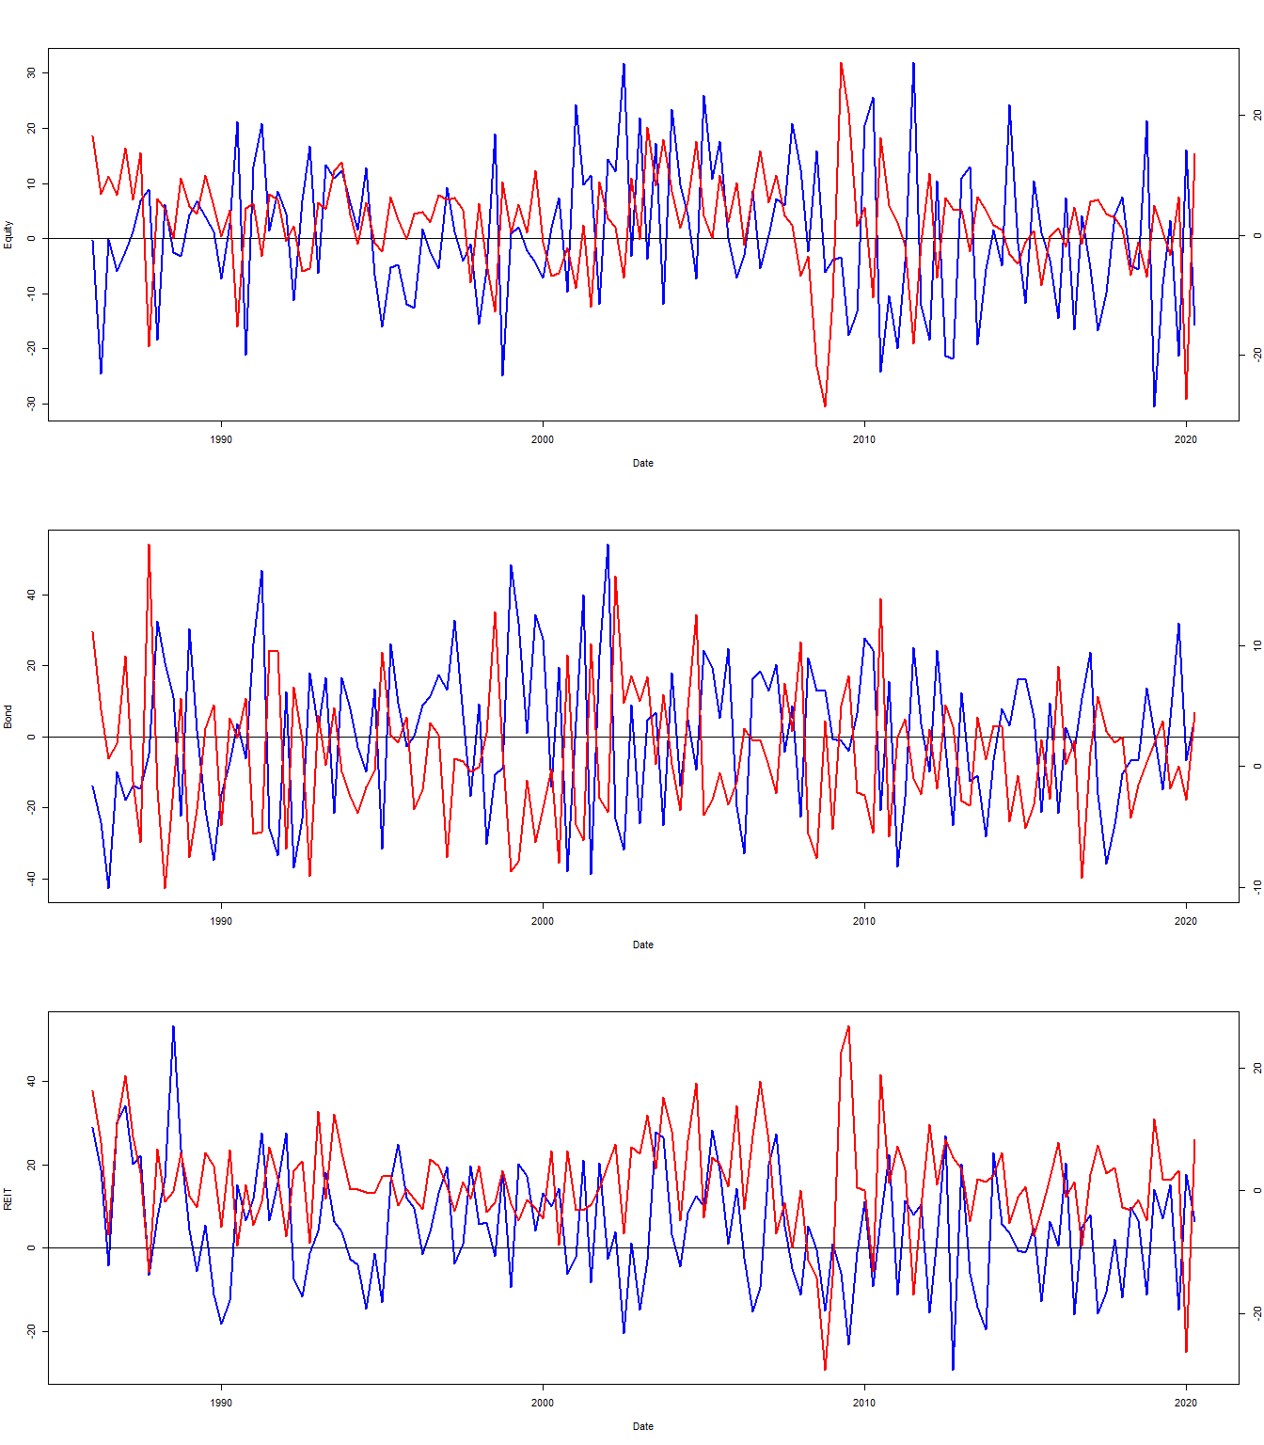

Appendix Fig 4

# Appendix Table 2

## Between the diversifications

## equity_bearbull bond_bearbull reit_bearbull  
## equity_bearbull 1.000 0.224 0.037  
## bond_bearbull 0.224 1.000 0.236  
## reit_bearbull 0.037 0.236 1.000

## With return

### Equity

## [1] -0.37

### Bond

## [1] -0.589

### REIT

## [1] 0.062

## pre 2007

### Equity

## [1] -0.315

### Bond

## [1] -0.608

### REIT

## [1] 0.153

## 2007-2012

### Equity

## [1] -0.463

### Bond

## [1] -0.67

### REIT

## [1] -0.09

post 2012

### Equity

## [1] -0.578

### Bond

## [1] -0.432

### REIT

## [1] -0.111

# Appendix Table 3

## Values

## [1] "Equity 0.614"

## [1] "Bond 0.458"

## [1] "REIT 5.004"

## t-stat

## [1] "Equity 0.558178274305191"

## [1] "Bond 0.261087393961802"

## [1] "REIT 4.20094558188775"

# Appendix Table 4

only time periods shared by all individuals are left in the result

## Global Internet

Equity

|  |  |  |
| --- | --- | --- |
|  | Estimate | P-Value |
| **TED** | -3.029 | 0 |
| **VIX** | -0.548 | 0 |
| **SENT** | 0.147 | 0.683 |
| **FEDFUNDS** | 0.732 | 0 |
| **INTERNET** | -0.248 | 0 |
| **ERM** | 0.516 | 0.71 |
| **EUROZONE** | -6.239 | 0 |
| **COVID** | -4.503 | 0.002 |
| **Adj. R sq** | 0.188 | NA |
| **N Obs.** | 9765 | NA |

Bond

|  |  |  |
| --- | --- | --- |
|  | Estimate | P-Value |
| **TED** | -1.263 | 0.303 |
| **VIX** | 0.034 | 0.618 |
| **SENT** | 0.081 | 0.898 |
| **FEDFUNDS** | 1.303 | 0 |
| **INTERNET** | 0.011 | 0.605 |
| **ERM** | 2.399 | 0.282 |
| **EUROZONE** | -3.607 | 0.014 |
| **COVID** | -3.373 | 0.2 |
| **Adj. R sq** | 0.021 | NA |
| **N Obs.** | 3137 | NA |

REIT

|  |  |  |
| --- | --- | --- |
|  | Estimate | P-Value |
| **TED** | -10.95 | 0 |
| **VIX** | -0.163 | 0.12 |
| **SENT** | 1.391 | 0.184 |
| **FEDFUNDS** | 1.966 | 0 |
| **INTERNET** | -0.303 | 0 |
| **ERM** | -12.14 | 0.002 |
| **EUROZONE** | -6.795 | 0.001 |
| **COVID** | -11.26 | 0.001 |
| **Adj. R sq** | 0.235 | NA |
| **N Obs.** | 1776 | NA |

## Local Internet

Equity

|  |  |  |
| --- | --- | --- |
|  | Estimate | P-Value |
| **TED** | -2.698 | 0 |
| **VIX** | -0.491 | 0 |
| **SENT** | 0.684 | 0.055 |
| **FEDFUNDS** | 1.024 | 0 |
| **INTERNET** | -0.204 | 0 |
| **ERM** | 0.405 | 0.769 |
| **EUROZONE** | -5.541 | 0 |
| **COVID** | -11.42 | 0 |
| **Adj. R sq** | 0.195 | NA |
| **N Obs.** | 9668 | NA |

Bond

|  |  |  |
| --- | --- | --- |
|  | Estimate | P-Value |
| **TED** | 0.312 | 0.804 |
| **VIX** | -0.05 | 0.465 |
| **SENT** | -0.259 | 0.685 |
| **FEDFUNDS** | 0.423 | 0.085 |
| **INTERNET** | -0.081 | 0 |
| **ERM** | -1.513 | 0.506 |
| **EUROZONE** | -3.319 | 0.026 |
| **COVID** | -3.314 | 0.198 |
| **Adj. R sq** | 0.028 | NA |
| **N Obs.** | 3057 | NA |

REIT

|  |  |  |
| --- | --- | --- |
|  | Estimate | P-Value |
| **TED** | -10.16 | 0 |
| **VIX** | -0.082 | 0.423 |
| **SENT** | 2.301 | 0.026 |
| **FEDFUNDS** | 1.879 | 0 |
| **INTERNET** | -0.248 | 0 |
| **ERM** | -14.31 | 0 |
| **EUROZONE** | -5.473 | 0.01 |
| **COVID** | -20.63 | 0 |
| **Adj. R sq** | 0.234 | NA |
| **N Obs.** | 1776 | NA |

## DEVPC1

Internet is the DEVPC1 factor

Equity

|  |  |  |
| --- | --- | --- |
|  | Estimate | P-Value |
| **TED** | -3.77 | 0 |
| **VIX** | -0.437 | 0 |
| **SENT** | 0.884 | 0.013 |
| **FEDFUNDS** | 1.292 | 0 |
| **INTERNET** | -0.076 | 0 |
| **ERM** | 2.65 | 0.051 |
| **EUROZONE** | -5.123 | 0 |
| **COVID** | -10.48 | 0 |
| **Adj. R sq** | 0.196 | NA |
| **N Obs.** | 9668 | NA |

Bond

|  |  |  |
| --- | --- | --- |
|  | Estimate | P-Value |
| **TED** | 0.318 | 0.796 |
| **VIX** | -0.061 | 0.358 |
| **SENT** | -0.417 | 0.51 |
| **FEDFUNDS** | 0.145 | 0.524 |
| **INTERNET** | -0.063 | 0 |
| **ERM** | -2.202 | 0.32 |
| **EUROZONE** | -3.42 | 0.021 |
| **COVID** | -1.714 | 0.504 |
| **Adj. R sq** | 0.039 | NA |
| **N Obs.** | 3057 | NA |

REIT

|  |  |  |
| --- | --- | --- |
|  | Estimate | P-Value |
| **TED** | -11.69 | 0 |
| **VIX** | 0.009 | 0.931 |
| **SENT** | 2.799 | 0.007 |
| **FEDFUNDS** | 2.952 | 0 |
| **INTERNET** | -0.082 | 0 |
| **ERM** | -8.425 | 0.029 |
| **EUROZONE** | -5.137 | 0.017 |
| **COVID** | -18.63 | 0 |
| **Adj. R sq** | 0.219 | NA |
| **N Obs.** | 1776 | NA |

# Pending

* Table 7 formatting